READ (R) |   Make sure you read the question, twice!
UNDERSTAND (U) |   What is it asking you to do? Could you explain it to someone else?
CALCULATE (C) | 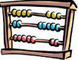  What calculation is needed? Have you estimated the answer?
SOLVE (S) |   What strategy are you going to use to solve the problem?
ANSWER (A) |   Have you clearly shown your answer?
CHECK (CK) | 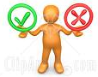  *Have you checked your calculation? Does it “look” right?

