School Day Timetable

Action | Analogue | Digital | Image | This takes me….
Get out of bed | 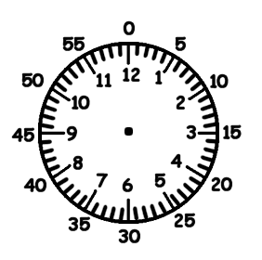 | : |  | hours mins
 |  | : |  | hours mins
 |  | : |  | hours mins
 |  | : |  | hours mins
 |  | : |  | hours mins
 |  | : |  | hours mins

