Selling Cakes

6 children from _______________ maths set decide they want to raise some money for ____________ School’s charity.

So they decide to make and sell cakes. Unfortunately they didn’t all manage to make the same number of cakes.

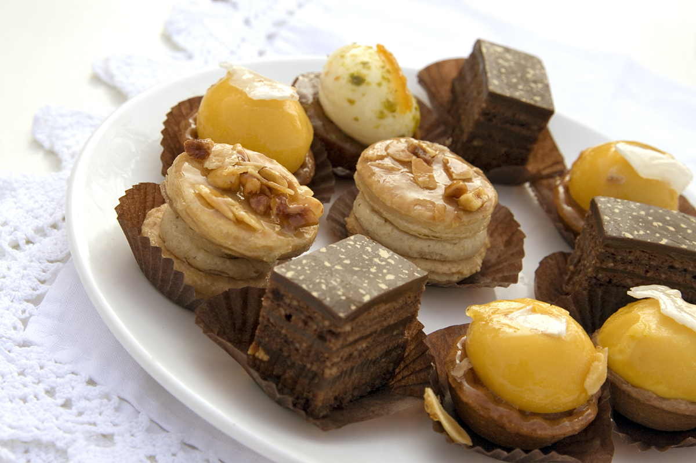
- Child A made 8 cakes

- Child B made 15 cakes

- Child C made 24 cakes

- Child D made 20 cakes

- Child E made 40 cakes

- Child F made 60 cakes

Clue 1
All the children want to raise the same amount of money what should each child sell their cakes for?

Each child decides that they want to raise between £10 and £15 each. What should each child sell their cakes for?

Clue 2

Clue 3
It is possible for each child to make exactly £12. How much should they sell their cakes for to do this?

