16.06.14
WALT: find fractions of shapes

Context: E3
GW
TA
T
I
WILF:

Using knowledge of thirds

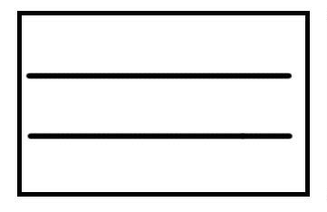
Calculate two thirds (²/₃) of shapes

Recording fractions carefully
