Name ____________________________ Date _______________________

How many counters can you hold in one hand?

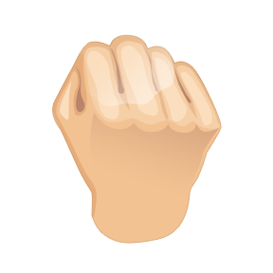 My guess How many I counted

How many cubes will fit in the bag?

My guess How many I counted

How many plastic animals will fit in the bag?

My guess How many I counted

How many glue sticks will fit in the bag?

My guess How many I counted

