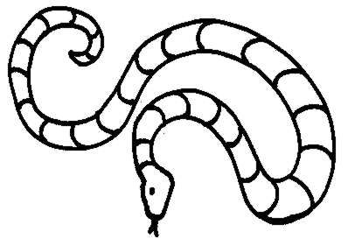

2
12
24
Can you fill in the 2 times table on my friends back?

6
12
33
Can you fill in the 3 times table on my friends back?
24

Can you fill in the 4 times table on my friends back?

Can you fill in the 5 times table on my friends back?

6
36
72
Can you fill in the 6 times table on my friends back?

7
42
70
Can you fill in the 7 times table on my friends back?

16
24
80
Can you fill in the 8 times table on my friends back?

Can you fill in the 9 times table on my friends back?

10
60
100
Can you fill in the 10 times table on my friends back?

11
66
110
Can you fill in the 11 times table on my friends back?

Can you fill in the 12 times table on my friends back?

