Mr Butterwood has a budget of £1000 to spend on a sofa and a chair to put in his house. Can you help him find a good deal by working through the pages in this booklet without using a calculator?

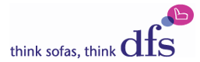
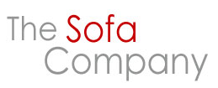

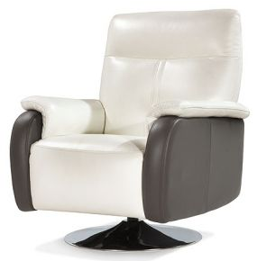
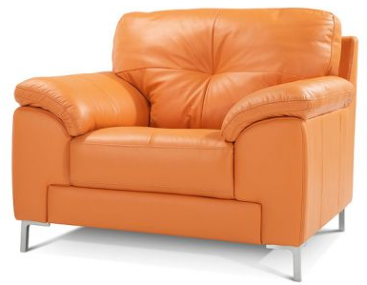
Price: £350.99
Price: £699.99

Price:
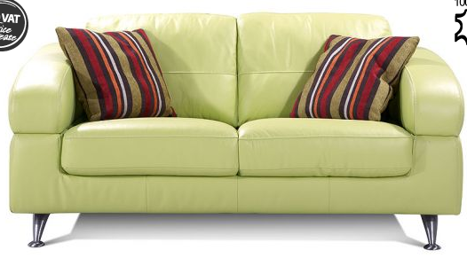
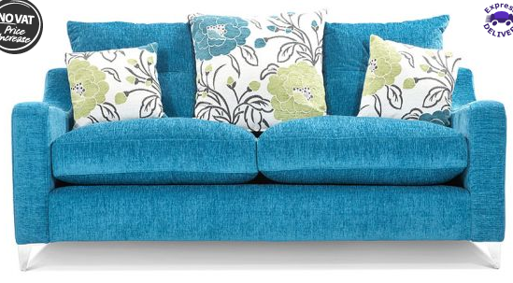

Price: £625.50
Price: £710.90


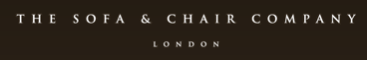

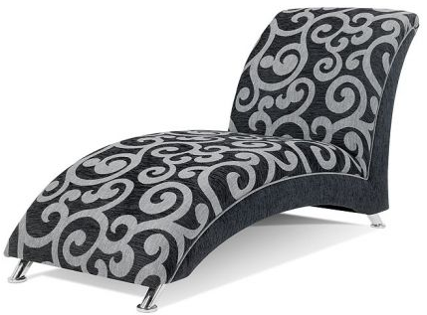
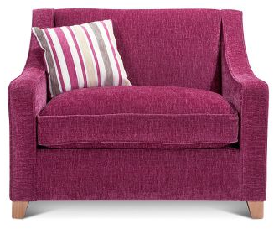

Price: £450.95
Price: £635.75

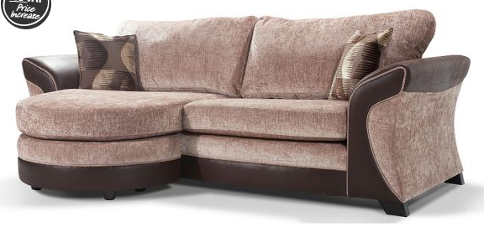
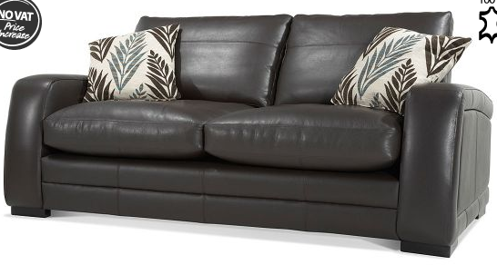

Price: £655.75
Price: £924.85
What is the total on both the sofa and the chair for each Each store asks for a £299.99 deposit for a sofa and one
company? (Use the plank boxes to show your working) chair. How much would be left to pay after paying the
deposit to each store?
(Use the blank boxes to show your working)
______________________

______________________

______________________

_____________________

Mr Butterwood’s budget is £1000. Put the companies into order starting with the cheapest to the most expensive and decide which company will save Mr Butterwood the most money.

If Mr Butterwood chose to buy his from DfS they offer him the opportunity of paying over a 3 year time period for both the chair and sofa. How much would he have to pay each week if he chose this option? Show your workings out in the space below.

Answer: ______________

