The strongest link
Children should be provided with A, B, C, D answer cards. Team tables. Tally scores. Team with highest score is the Strongest Link!

1. We would weigh an elephant using:

- Grams
- Kilograms
- Metres
- Litres

2. We would weigh a yoghurt using:

- Litres
- Grams
- Kilograms
- Centimetres

3. What is 5 x 11

- 50
- 5
- 500
- 55

4. What fraction is coloured?

- A quarter ¼
- A half ½
- A third 1/3
- Three quarters

5. What is two quarters the same as?

- A whole
- A third
- A half
- An eighth

6. What is 35 x 10?

- 3
- 350
- 3500
- 30

7. What is 35 x 100?

- 3
- 350
- 3500
- 30

8. If you share 12 chocolate drops between 4 people, how many chocolate drops will each person get?

- 3
- 4
- 5
- 6

9. What is 10 x 12?

- 12
- 120
- 102
- 122

10. How many grams make a kilogram?

- 1g
- 10g
- 100g
- 1000g

11. How many grams is half a kilogram?

- 100g
- 200g
- 500g
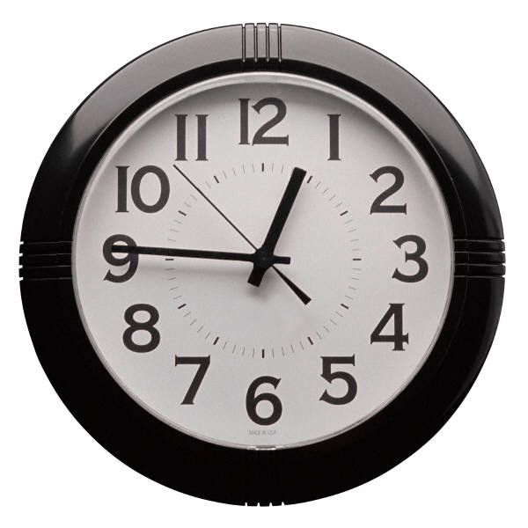
- 750g

12. What time is shown?

- Twelve forty-five
- One forty-five
- Two o’clock
- Six o’clock
10 30
13. What will the time be one hour later?

- Four thirty
- Half past eleven
- Twelve thirty
- Thirty minutes past nine

14. What might you be doing at 9.00 am on a weekday?

- Eating your lunch
- Sleeping
- Riding a horse
- Doing your learning journals

15. Where is north?
N
A.

B.
N
N
N
C.

D.

16. If I start facing South and turn a quarter turn clockwise, which way will I be facing?

- North
- West
- South
- East

