Name _________________________ Date _____________________
11
5
=
-

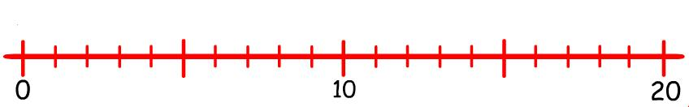

8
4
=
-

12
5
=
-

11
3
=
-

17
6
=
-

16
7
=
-

9
7
=
-

14
5
=
-
13
4
=
-
11
7
=
-

