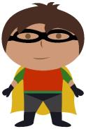

1
5
11
14
6
17
20
7
12
15
2
19
10
3
8
13
4
18
16
9
0-20 ordering activity.
Cut and stick the superheroes into the correct order.

