Take away cupcakes!

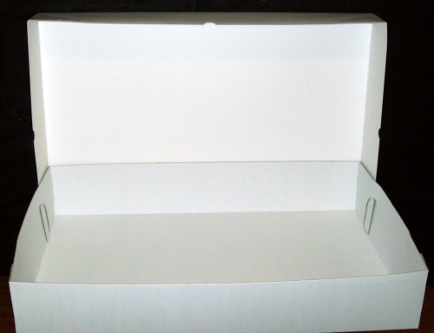

3 – 2 = 1



5 - 3 =

6 – 3 =

4 - 2 =

7 – 4 =

