The Tooth Fairy
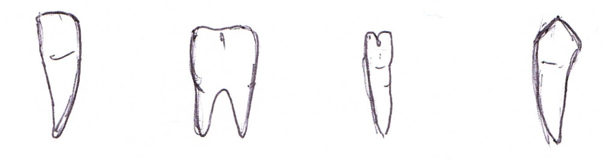
Incisor Molar Pre-Molar Canine
£1.25 £1.50 £1.00 £2.00

The tooth fairy has left £5 under your pillow.

What combination of teeth could you have left for her?
Record in your books.
The Tooth Fairy
Incisor Molar Pre-Molar Canine
25p 50p 75p 10p

The tooth fairy has left £1 under your pillow.

What combination of teeth could you have left for her?
Record in your books.
The Tooth Fairy
Incisor Molar Pre-Molar Canine
10p 5p 20p 2p

The tooth fairy has left 50p under your pillow.

What combination of teeth could you have left for her?
Record in your books.
The Tooth Fairy
Incisor Molar Pre-Molar Canine
10p 5p 2p 1p

The tooth fairy has left 20p under your pillow.

What combination of teeth could you have left for her?
Record in your books.
The Tooth Fairy
Incisor Molar Canine
1p 2p 5p

The tooth fairy has left 10p under your pillow.

What combination of teeth could you have left for her?
Record in your books.

