Time Patterns Challenge

1. Write the missing time in the sequence:
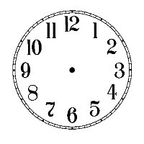

2. Write the missing time in the sequence:

3. Write the missing time in the sequence:

4. Write the missing time in the sequence:

5. Write the missing time in the sequence:

Digital Time Challenge

1. Write the missing time in the sequence:

7:30
:
9:30
10:30
11:30

2. Write the missing time in the sequence:

2:15
2:30
:
3:00
3:15

3. Write the missing time in the sequence:

8:20
8:30
8:40
8:50
:

4. Write the missing time in the sequence:

:
12:55
1:00
1:05
1:10

5. Write the missing time in the sequence:

5:45
6:05
6:25
:
7:05

