
Time problems
- I left home at 5 past 2 and arrived at Jean’s house 10 minutes later.
What time did I arrive at Jean’s house?
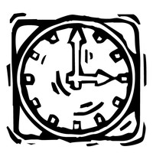

- It is 3 o’clock. What time will it be in 15 minutes?

- On Thursday it takes 10 minutes to take the class register. We start at 15 minutes past 1. What time do we finish?

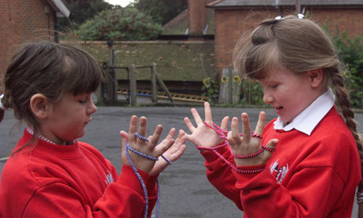
- Playtime starts at 15 minutes past 10 and finishes at half past 10. How long is playtime?

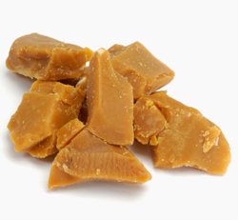
- I start chewing my toffee at 20 past 12 and it takes me 5 minutes to finish it. How long did it take me to eat the toffee?


- Amy started walking at 25 minutes past 10, she took 15 minutes to walk to school. What time did she arrive?

