What’s the total?
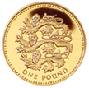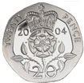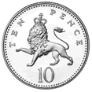 | 100 + 20p + 10p =130p | £1.30
 |  | £ .
 |  | £ .
 |  | £ .
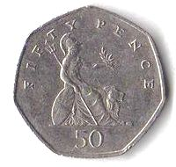
WALT: Add coins to find a total. WT A E 10.02.10

What’s the total?
WALT: Add coins to find a total up to 10p. WT A E 10.02.10

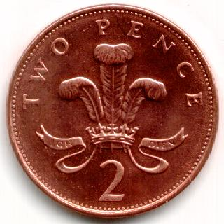 | 2p + 2p + 2p = 6p
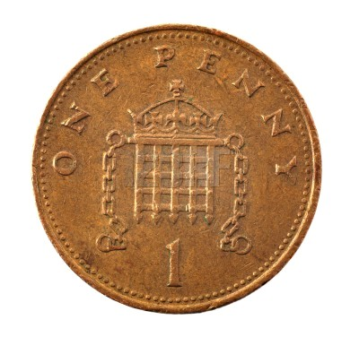

What’s the total?
WALT: Add coins to find a total up to 20p. WT A E 10.02.10

10p + 2p + 2p = 14p

What’s the total?
WALT: Add coins to find a total up to 10p. WT A E 10.02.10

 | 2p + 2p + 2p = 6p
 | 5p + 2p + 1p = p
 | 2p + 2p + 1p = p
 | 5p + 2p + 2p = p
 | 1p + 1p + 1p =
 | 2p + 2p + 1p =
 | 5p + 5p =
5 | 5p + 1p + 1p =

