Transfer Market

Write Robinho’s transfer fee in digits. He cost Manchester City thirty two million, five hundred thousand pounds.
HYPERLINK "http://images.google.co.uk/imgres?imgurl=http://www.robinho-soccer.com/robinho.jpg&imgrefurl=http://www.robinho-soccer.com/&h=371&w=600&sz=63&hl=en&start=4&um=1&usg=__sGqU-8EBJAj2rBpkrV4mWSWvX4U=&tbnid=-cDAK8hMXKKsBM:&tbnh=83&tbnw=135&prev=/images%3Fq%3DROBINHO%26um%3D1%26hl%3Den%26sa%3DN" INCLUDEPICTURE "http://tbn0.google.com/images?q=tbn:-cDAK8hMXKKsBM:http://www.robinho-soccer.com/robinho.jpg" \* MERGEFORMATINET 

Berbatov cost Manchester United thirty million, seven hundred and fifty thousand pounds. Write his transfer fee in the box.
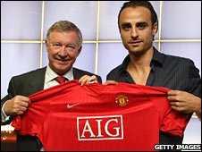

Chelsea spent £7,900,250 on Deco. Change these digits into words.



Liverpool sign Torres for an estimated £23,500,010. Change these numbers into words.


The most expensive player ever bought cost forty five million, three hundred and twenty five thousand, five hundred and ninety five pounds. Write these words in figures.
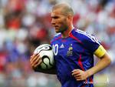

Estimate how much these players are worth in figures

1. David Beckham

2. Cristiano Ronaldo

3. Peter Crouch

4. Ronaldinho

5. Wayne Rooney

6. Thierry Henry

7. Glauber Bertie

