I
What are the coordinates for Treasure Island?
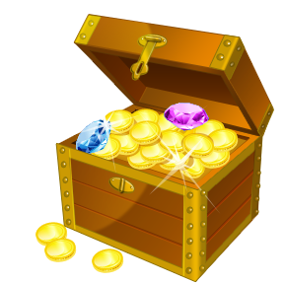 ( ) ( ) ( ) ( )
Put an X on the grave of ‘Blind Pete’( H6) – Plant a flag (O5) – Where is the pirate ship? ( ______ )
8
7
6
5
4
3
2
1
 | A | B | C | D | E | F | G | H | I | J | K | L | M | N | O | P | Q

