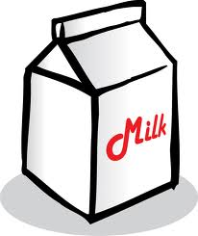
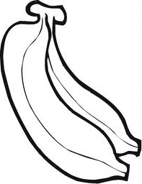
Year 3 Trip to the shops
LO: To understand weights and measures.
Look at your shopping list and find what unit of measure it is sold in.
Estimate weight | Actual weight | Estimate cost | Actual cost
 |  |  |  | loaf of bread
 |  |  |  | bag of apples
 |  |  |  | packet of coffee
 |  |  |  | packet of oats
 |  |  |  | largest cornflakes packet
 |  |  |  | smallest cornflakes packet
 |  |  |  | carton of milk
 |  |  |  | packet of cheese
 |  |  |  | jar of jam
 |  |  |  | packet of rice
 |  |  |  | packet of pasta
 |  |  |  | tin of tomatoes
 |  |  |  | small carton of juice
 |  |  |  | large bottle of lemonade
 |  |  |  | small bottle of water
 |  |  |  | large packet of flour
 |  |  |  | packet of sugar
 |  |  |  | hair spray
 |  |  |  | shampoo
 |  |  |  | hand soap
 |  |  |  | washing up liquid
 |  |  |  | small packet of wash powder
 |  |  |  | large packet of wash powder

Now find something that is
- Exactly 1kg ___________________________
- Less than 1kg _________________________
- More than 1L _________________________
- Less than 1L __________________________
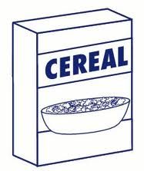
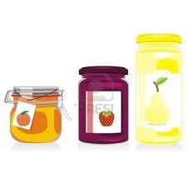

Name:________ Form:__________

My trip to the shops
LO: While at the shops we will be looking at how much food items cost, and how they are measured.

When we measure length we measure in ________________ .
When we measure weight we measure in ________________ .
When we measure money we measure in ________________ .
When we measure liquids we measure in ________________ .
Facts to remember
There are _______ g in 1Kg
There are _______ ml in 1L
There are _______ cm in 1m
There are _______ m in 1Km
There are ________ c in 1€

Measuring length
On the way to the shops we will be measuring how far it is to walk.
So that we can count this easily we are going to see how many steps it takes us to travel 10m.

It takes me ____________ normal steps to travel 10 metres.

Estimating length
I estimate the length of the school fence to be ________ metres.
I estimate that it will be __________ metres to walk from here to Kaisers.

Tally charts
A tally chart to show how many steps it took to walk to Kaisers.
Each tally is worth 10m ( ______ number of steps makes 10m)

Number of steps

