LI: I can recognise and use whole, half and quarter turns, both clockwise and anticlockwise; know that a right angle represents a quarter turn


Start
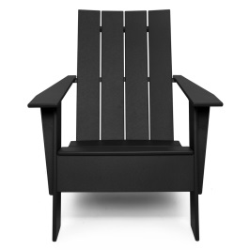
Start

Start

Start

LI: I can recognise and use whole, half and quarter turns, both clockwise and anticlockwise; know that a right angle represents a quarter turn

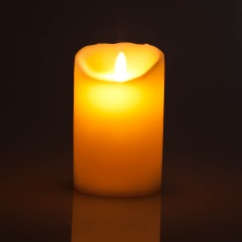
Start | Half turn | Quarter turn clockwise | Full turn
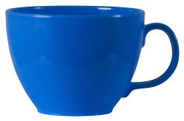
Start | Quarter turn anti-clockwise | Half turn | Full turn

Start | Quarter turn clockwise | Full turn | Half turn

Start | Full turn | Half turn | Quarter turn anti-clockwise

Start | Half turn | Full turn | Quarter turn clockwise

