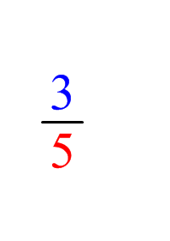
Proper fraction:

The numerator is
SMALLER than
the denominator.
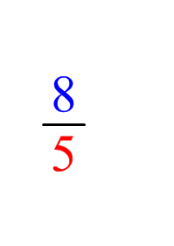
Improper fraction:

The numerator is
BIGGER than
the denominator.
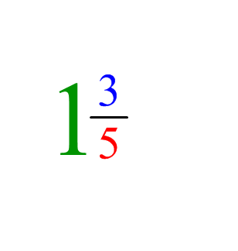
Mixed fraction:

A whole number
and a proper fraction.

