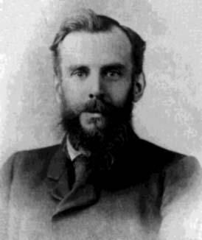
Venn Diagrams
Mr John Venn
1834 - 1923

Sort the information given into these Venn Diagrams

Blue
1 Football teams and their kits

Arsenal Red
Everton Blue
Chelsea Blue
Liverpool Red
Red
Man. City Blue
Blackburn Blue and Red
Tottenham White

2 Favourite crisp flavours

Abbey Salt ‘n’ Vinegar and Plain
Brian Plain
Plain
Prawn Cocktail
Salt ‘n’ vinegar
Chad Prawn Cocktail and Plain
Debbie Salt ‘n’ Vinegar
Ed Bacon
Fran Cheese and Onion and Plain
Geoff Salt ‘n vinegar, plain and prawn
cocktail.

3 Collect your own data about number of
Boys
Girls
More than 6 letters
letters in 10 people’s names,
one is done for you…

Daniel

