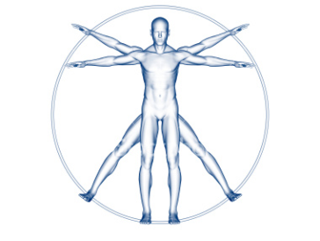
Name
Sheet 1
Are you Leonardo da Vinci’s Vitruvian Man?
- Make sure that you have the right measuring tool for what you are measuring. Do you need a tape measure or a ruler or a metre stick?
- Check that you start measuring at zero and then read the number that is as close as possible to the end of what you’re measuring. Be accurate!
- When you write your results, make sure that you include the units of measurement: mm, cm, and m.
- Answer the question in the last column.
What to measure | Measurement | Question
The width of your palm |  | Are these 2 the same?
The width of four fingers |  | Are these 2 the same?
Your height |  | Are these 3 the same?
The distance from fingertip to fingertip with your arms outstretched. |  | Are these 3 the same?
The distance from your hairline (where your forehead stops and the hair begins) to the bottom of your chin. Now multiply by 10.  Challenge: Now investigate one of your choice. |  | Are these 3 the same?
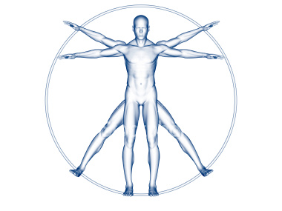
Name
Sheet 2
Are you Leonardo da Vinci’s Vitruvian Man?
- Make sure that you have the right measuring tool for what you are measuring. Do you need a tape measure or a ruler or a metre stick?
- Check that you start measuring at zero and then read the number that is as close as possible to the end of what you’re measuring. Be accurate!
- When you write your results, make sure that you include the units of measurement: mm, cm, and m.
- Answer the question in the last column.

What to measure | Measurement | Question
Your height |  | Are these 4 the same?
The distance from fingertip to fingertip with your arms outstretched. |  | Are these 4 the same?
The width of your palm. Multiply by 24. |  | Are these 4 the same?
The distance from your hairline (where your forehead stops and the hair begins) to the bottom of your chin. Now multiply by 10. |  | Are these 4 the same?
The length of your hand from the bottom of your palm to the tip of your longest finger. |  | Is this a tenth of your height?
The distance from your elbow to the tip of your longest finger. |  | Is this a quarter of your height?
Challenge: Now investigate one of your choice.
Name
Sheet 3
Are you Leonardo da Vinci’s Vitruvian Man?
- Make sure that you have the right measuring tool for what you are measuring. Do you need a tape measure or a ruler or a metre stick?
- Check that you start measuring at zero and then read the number that is as close as possible to the end of what you’re measuring. Be accurate!
- When you write your results, make sure that you include the units of measurement: mm, cm, and m.
- Answer the question in the last column.
What to measure | Measurement | Question
Your height |  | Are these the same?
The distance from fingertip to fingertip with your arms outstretched. |  | Are these the same?
The width of your shoulders. |  | Is this 1/4 of your height?
The distance from your elbow to your armpit. |  | Is this 1/8 of your height?
The length of your foot from your heel to the tip of your longest toe. |  | Is this 1/6 of your height?
The distance from the top of your head to the bottom of your chin. |  | Is this 1/8 of your height?

Challenge: Now investigate one of your choice.

Vitruvian Man Proportions
- a palm is the width of four fingers
- a foot is the width of four palms (i.e., 12 inches)
- a cubit is the width of six palms
- a pace is four cubits
- a man's height is four cubits (and thus 24 palms)
- "erit eaque mensura ad manas pansas"
- the length of a man's outspread arms (arm span) is equal to his height
- the distance from the hairline to the bottom of the chin is one-tenth of a man's height
- the distance from the top of the head to the bottom of the chin is one-eighth of a man's height
- the distance from the bottom of the neck to the hairline is one-sixth of a man's height
- the maximum width of the shoulders is a quarter of a man's height
- the distance from the middle of the chest to the top of the head is a quarter of a man's height
- the distance from the elbow to the tip of the hand is a quarter of a man's height
- the distance from the elbow to the armpit is one-eighth of a man's height
- the length of the hand is one-tenth of a man's height
- the distance from the bottom of the chin to the nose is one-third of the length of the head
- the distance from the hairline to the eyebrows is one-third of the length of the face
- the length of the ear is one-third of the length of the face
- the length of a man's foot is one-sixth of his height

