What time is it on?

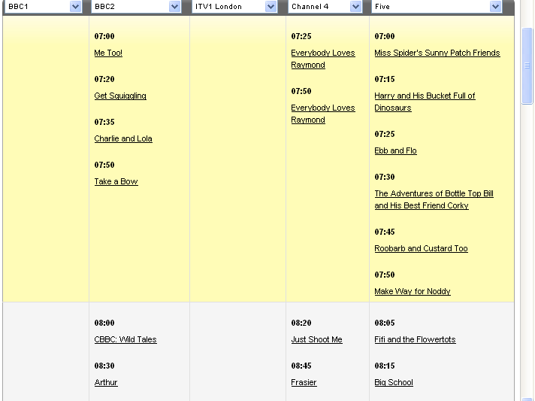
TV guide courtesy of onthebox.com

1) What time is Make Way For Noddy on? _________________________________________

2) How long does Charlie and Lola last for?
_________________________________________

3) Name two programmes that start at the same time.
_________________________________________

4) Name two programmes that last for the same amount of time.
_________________________________________

5) How long does Just shoot me last for?
_________________________________________

6) Take a bow starts at 07:50. How long after this does Frasier start?
_________________________________________

7) On the clocks below draw the time that the programmes beneath start.
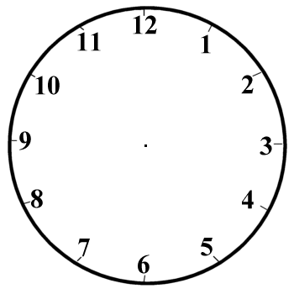
Ebb and Flow
Just Shoot me
Charlie and Lola
Fifi and the flowertots

