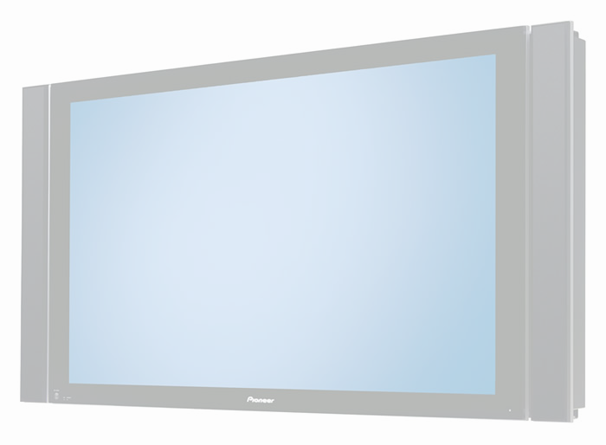
What are you going to watch tonight?

Imagine you have a HUGE plasma TV and it’s down to you to decide what you watch on TV this evening.
Use the TV guide to help you decide and write your plan on the television below.

Name of Programme | Start Time | Finish Time | Length of Programme

What is the total time you will spend watching TV this evening? ___________ Hours _____________ Minutes

