Name:____________________ Date:____________________

What Time is it?
Can you put the hands and numbers in the right place on these clocks?

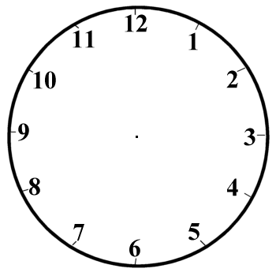
:
:
:

6 o’clock 7 o’clock 10 o’clock

:
:
:

3 o’clock 5 o’clock 9 o’clock
:
:
:

1 o’clock 11 o’clock 12 o’clock

Name__________________ Date________________
Telling the Time

:
:
:

3 o’clock 5 o’clock 9 o’clock

:
:
:

Half past 10 Half past 8 Half past 12

:
:
:

Half past 9 Half past 3 Half past 5

:
:
:

Quarter past 1 Quarter past 7 Quarter past 8
:
:
:

Quarter past 2 Quarter past 11 Quarter past 4
:
:
:

Quarter to 5 Quarter to 10 Quarter to 12
:
:
:

Quarter to 3 Quarter to 7 Quarter to 9

