Word Problems
Read each question, write the calculation in your book, work it out and then answer the question in a full sentence.
e.g. We went to the zoo and saw 6 camels, 17 flamingos, 24 elephants, and 8 giraffes. How many animals did we see altogether?
6 + 17 + 24 + 8 = 55
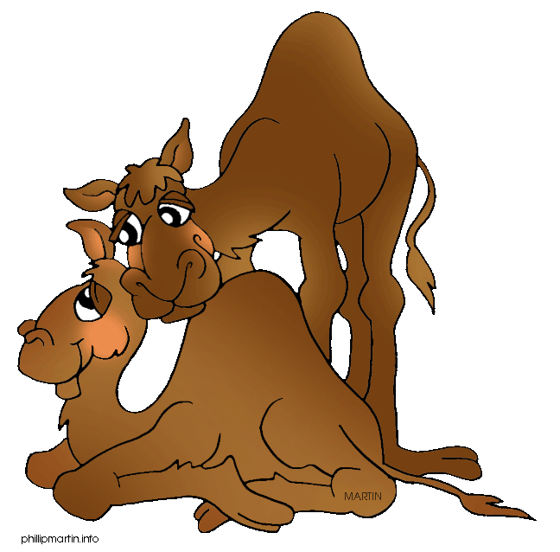
We saw 55 animals altogether.
- We went to the zoo and saw 5 camels, 9 flamingos, 18 elephants, and 6 giraffes. How many animals did we see altogether?
- At the zoo, I bought some carrots for the snakes. I kept 22 carrots and gave my friend 9. How many carrots did I buy in total?
- Each bag of carrots cost 20p. How much would 9 of them cost?
- We saw 17 adult hippos and 7 baby hippos. How many hippos did we see altogether?
- It cost us £4.50 each to get into the zoo. Three of us went. What was the total cost?
- We went to the zoo and saw 6 camels, 19 flamingos, 21 elephants, and 25 giraffes. How many animals did we see altogether?
- Each bag of apples cost 35p. How much would 6 of them cost?
- It cost us £2.25 each to get into the fair. Four of us went. What was the total cost?
- Each bag of crisps cost 55p. How much would 5 of them cost?
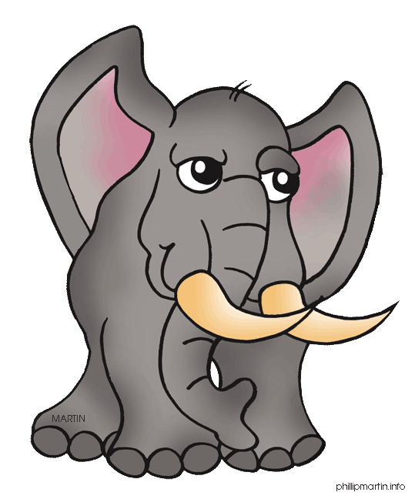
- Sam bought nine sandwiches costing 20p each. How much change did he get from £2.00?

