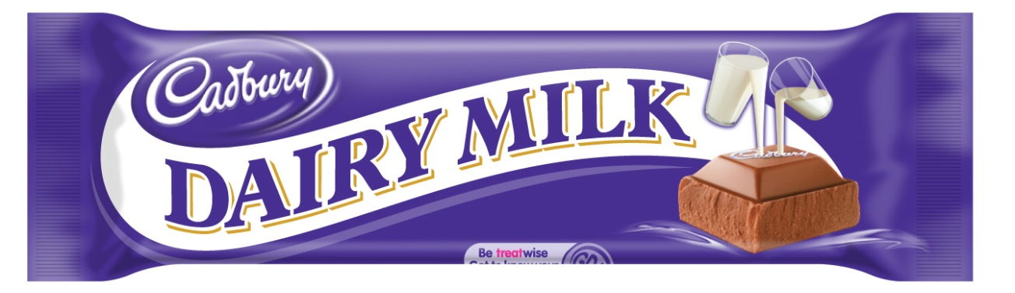
Would you rather have.....? circle the biggest fraction

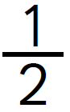 or 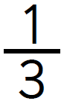 or 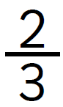

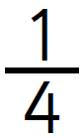 or 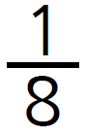 or

or or 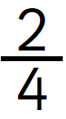

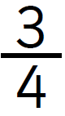 or or

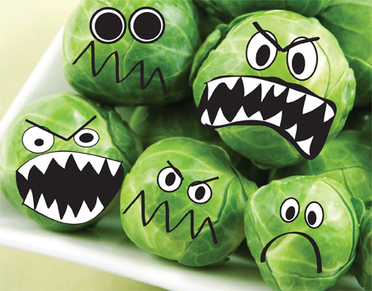

Would you rather have.....? Circle the smallest fraction

or or

or or

or or

or or
Circle the biggest fraction

or or

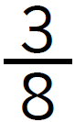 or 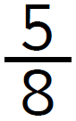 or

or or

or or

or or

