Using written methods for addition
If I am trying to add two large numbers and I can’t do it in my head, I can use either a partitioning or a column method.
For example, 456 + 378
- PARTITIONING METHOD:
I start by partitioning the number into Hundreds, Tens and Units:
456 = 400 + 50 + 6
378 = 300 + 70 + 8
Now I add up the Hundreds, Tens and Units separately:
H 400 + 300 = 700
T 50 + 70 = 120
U 6 + 8 = 14
Then I add these back together
700 + 120 + 14 = 834

- COLUMN METHOD:
I start by writing the two numbers one on top of the other, making sure each column is correctly lined up:
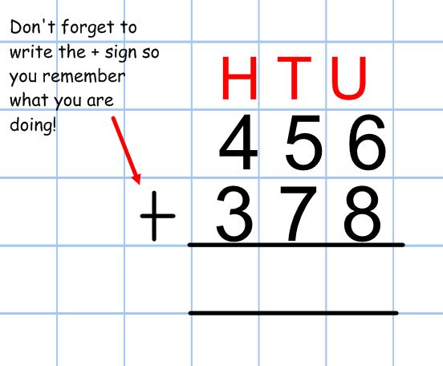
I always add up the numbers on the RIGHT first. In this case, it’s the units column. 6 + 8 = 14. 14 is actually 1 ten and 4 units. So I put 4 in the units column and add an extra 1 to the tens column:
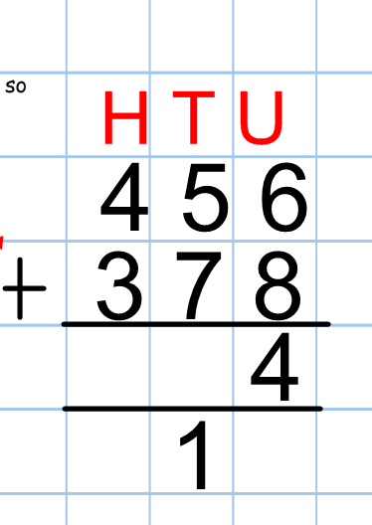
Next, I add the tens together. There are 5 tens + 7 tens + 1 ten (the extra one!). This equals 13 tens, which is the same as 130. That’s 1 hundred and 3 tens.
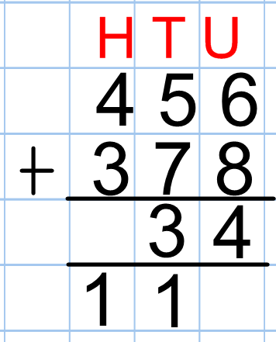
Finally, I add up the hundreds. 4 hundreds + 3 hundreds + the 1 extra hundred = 8 hundreds.
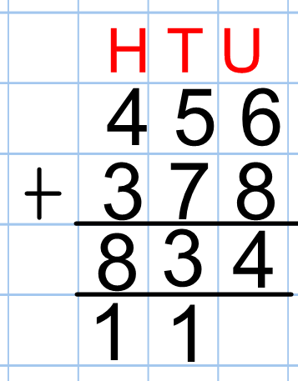 And there’s my answer!
Using written methods for subtraction
We have learnt two different methods for written subtraction: using a number line and column subtraction.
For example: 578 - 95
- NUMBER LINE METHOD:
I start by drawing a line and putting the larger number on the RIGHT hand side:

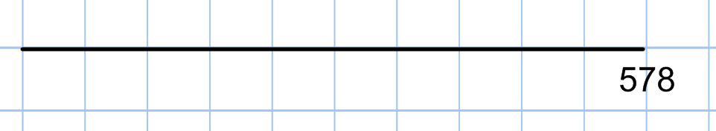
I am going to take away 95, by jumping backwards in small chunks. It is up to you which chunks you choose. I am going to show you just one option.
I would start by taking away 70 (because there are 7 tens in the number 578):
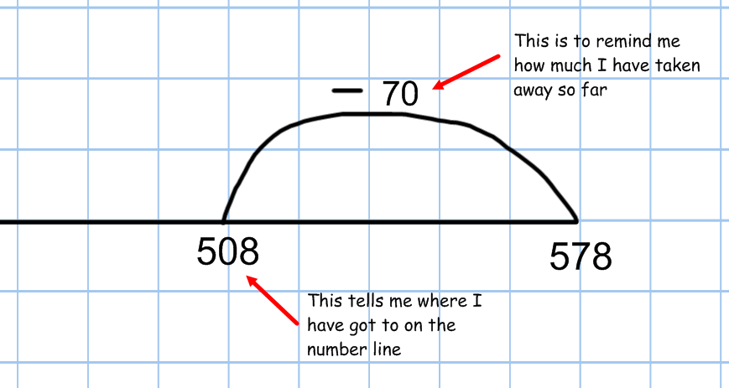
I have taken away 70, and I want to take away 95 in total. Next I would jump back another 20 (so that I have taken away all the tens that I need to):
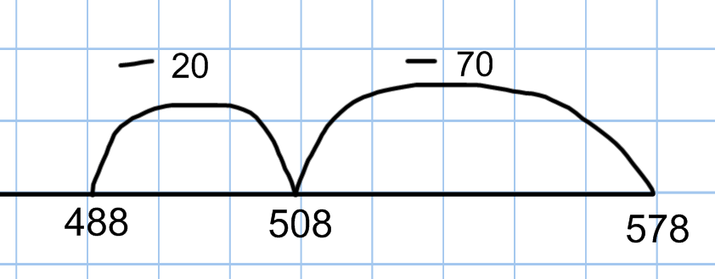
Now I have jumped back 90, so I only have 5 more to take away.
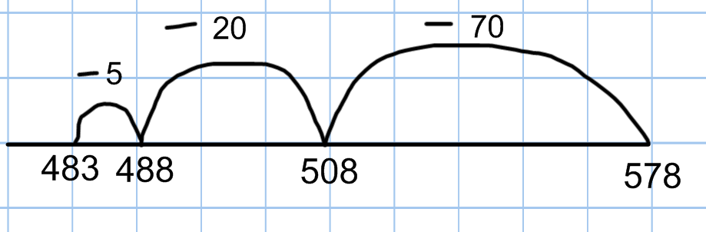
I’ve found my answer! I took away 70, then 20, then 5 (so 95 altogether) and ended up at 483.

- COLUMN METHOD:
Just like with addition, I line up the two numbers, one on top of the other. The most important thing to remember is that the BIGGEST number goes at the top.
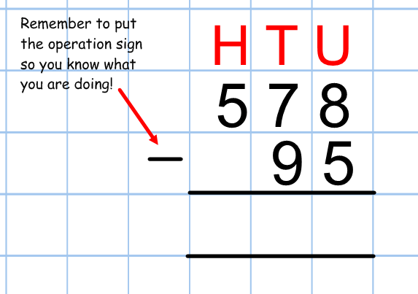
I always subtract the numbers on the RIGHT first. In this case, it’s the units column. 8 – 5 = 3.
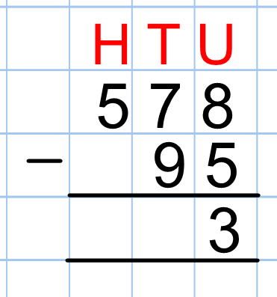
Next I subtract the tens column. 7 tens – 9 tens. Uh Oh! There’s a problem! 7 tens is smaller than 9 tens, so I can’t subtract the 9 tens. But…there are plenty of hundreds! So I am going to ‘borrow’ one of the hundreds.
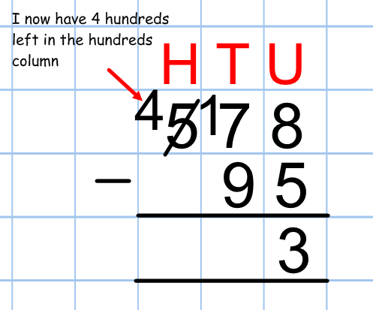
If I take one of those hundreds and put it with the 7 tens I already have, I then have 1 hundred and 7 tens (or 17 tens or 170), which is enough to take away 9 tens (or 90). So 17 tens – 9 tens = 8 tens.
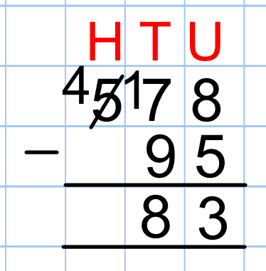
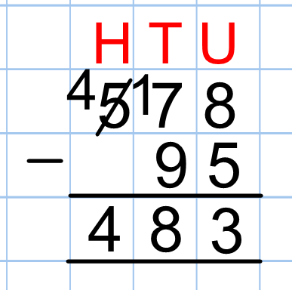
Now all I need to do is look at the hundreds column: 4 hundreds subtract nothing! Well, that’s easy!
There’s my answer!

