Miss Foster has 4 cups. She finds 2 more. How many cups does she have all together?  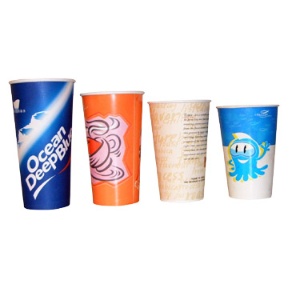  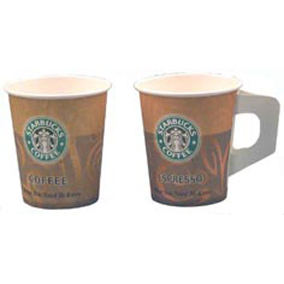 | Kyle has 10 sweets. He eats 5 sweets. How many are left?  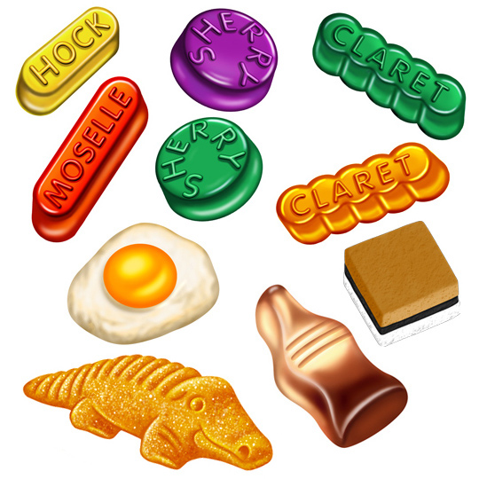 | Joy has 3 books. Evelyn gives her 3 more. How many books does Joy have now?  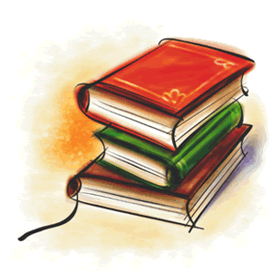 | A hen lays 4 eggs. She lays 6 more. How many eggs are there?  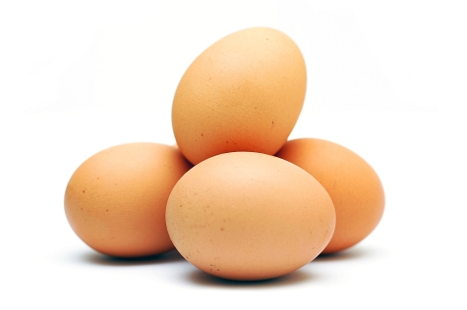  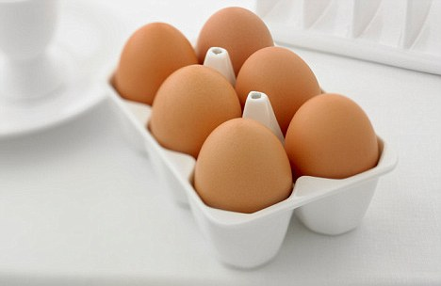
There are 9 butterflies. 1 more comes along. How many butterflies are there now?  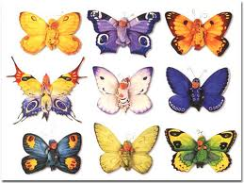  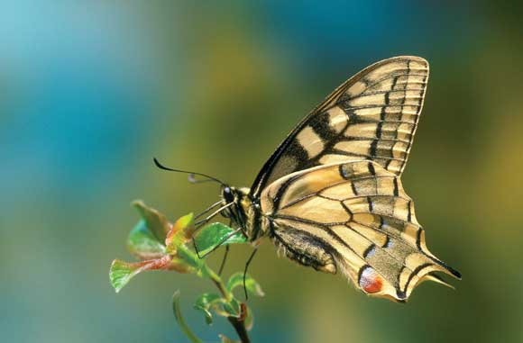 | Nissi has 3 umbrellas. Evelyn has 4. How many umbrellas do they have all together?  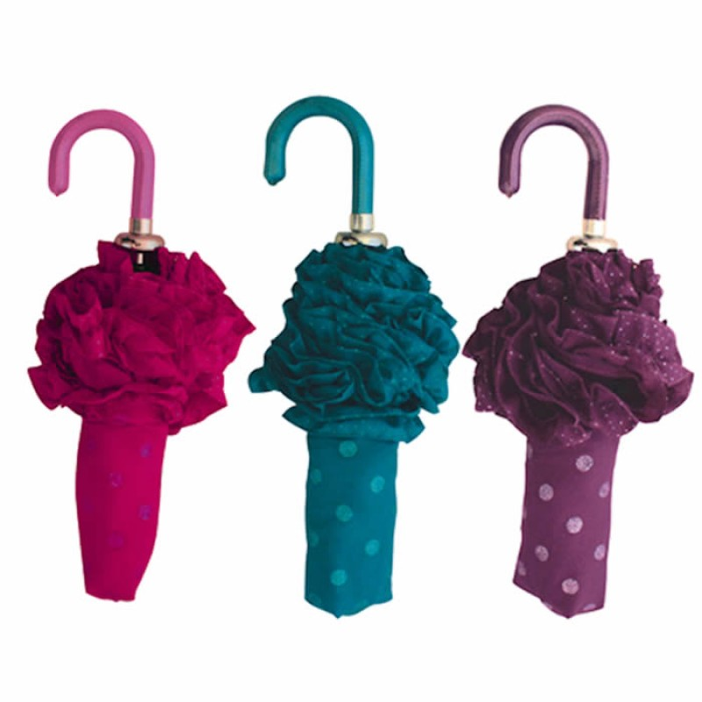  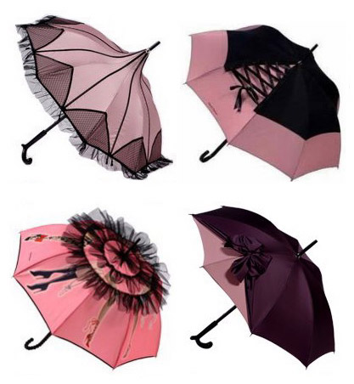 | Nzea has 9 toy cars. He breaks 3. How many toys cars does he have left?  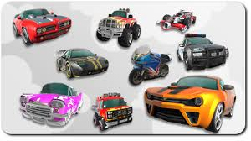 | Benjamin has 20 marbles. He loses 10 marbles. How many marbles does he have left?  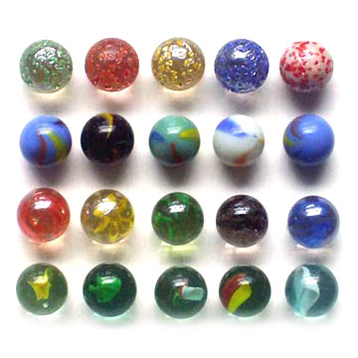
Destiny has 4 umbrellas. She breaks 1 umbrella. How many does she have left? | Irmak has 2 teddy bears. She gets 2 more for Christmas. How many teddy bears does she have?  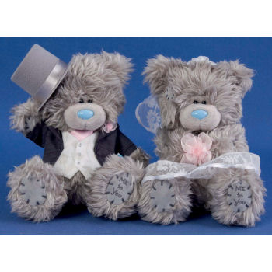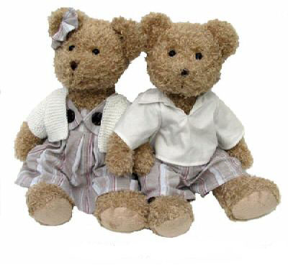 | Kevin has 3 hats. Dontay has 3 hats. How many hats do they have all together?  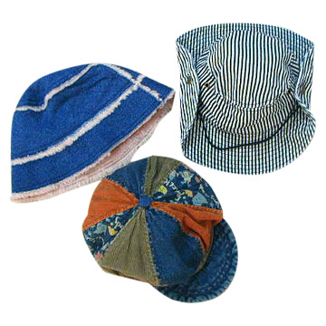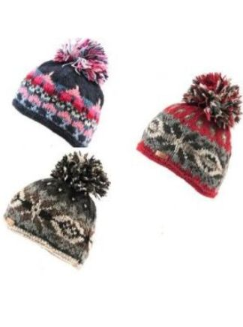 | Tony has 3 pens. 2 go missing. How many pens does Tony have?  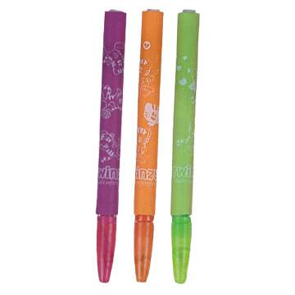
Arda has 3 apples. Coby has 2 more. How many apples are there all together?  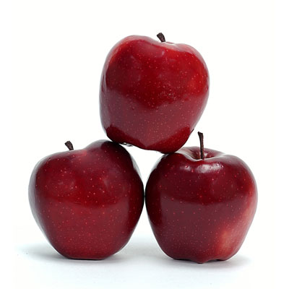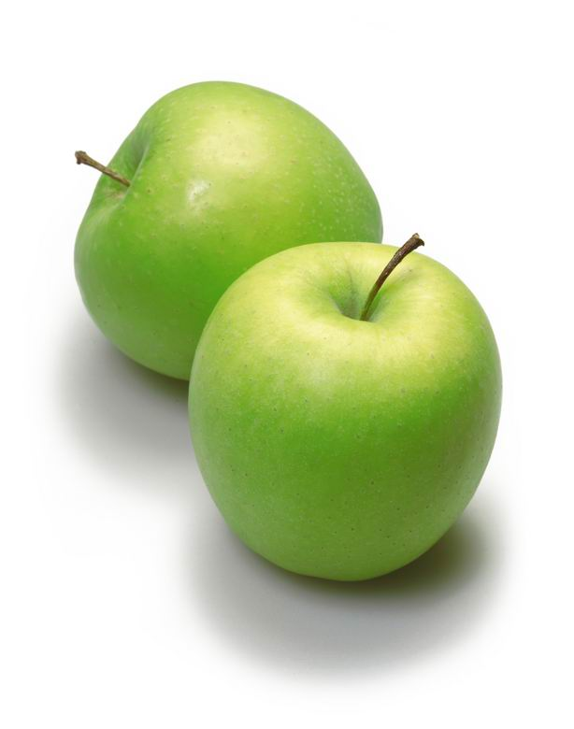 | Devrim has 6 shoes. He loses 2. How many does he have left?  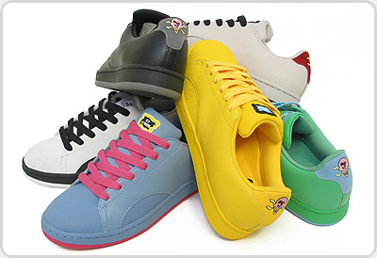 | There are 10 children on the bus. 3 children get off the bus. How many children are still on the bus? | There are 8 children sitting at a table. 2 more children join the table. How many children are sitting at the table?

