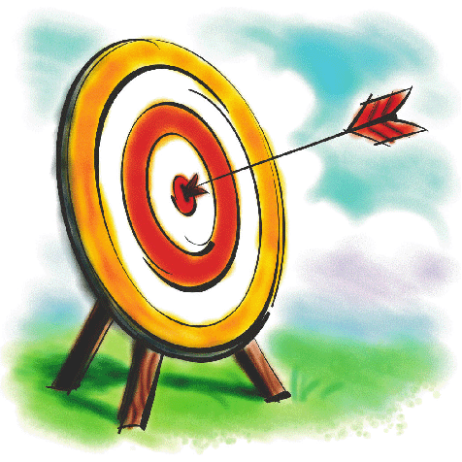
Name:
Y1 Numeracy Assessment Spring

Draw 18 snakes. Check your answer.

Fill in the missing numbers:

8 9 10 11 ___ ____ 14 ___ ___ 17 ____ _____ 20

Put these numbers in the right order, starting with the smallest:

7 12 4 16 19 1 = ______________________________

One more than 6 is ____

One less than 8 is _____

Two more than 5 is _____

Two less than 10 is _____

One more than 15 is _____

One less than 19 is _____

Colour half of this oblong:

What comes next? 10 20 30 40 ____
What comes next? 40 50 60 ____
What comes next? 80 70 60 ____

Finish this number bug.

10
5 + 5

Double 2 =
Double 3 =
Double 4 =
Double 10 =

What is half of 10? _______

Use a numberline or drawings to help you work out the answers to these questions:

3 + 4 = ___

5 + 3 = ___

10 – 4 = ___

8 – 6 = ___

13 + 8 = ___

21 + 5 + ___

27 – 6 = ___

19 – 10 = ___

Using drawings or cubes to help.

How many apples are there in 3 groups of 2? _____

How many children are there in 4 groups of 3? _____

What are these shapes called? Use these words to help:
oblong triangle hexagon pentagon cube pyramid circle

Draw these times.
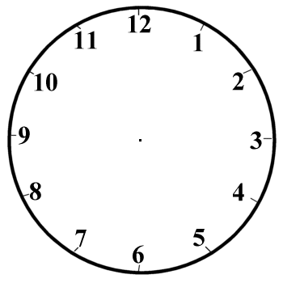

9 o’clock Half past 4 Half past 10

