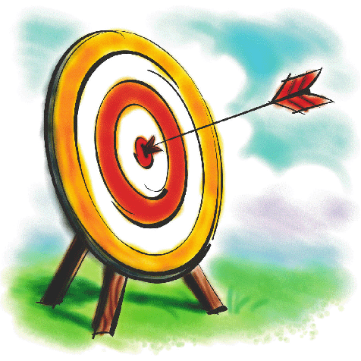
Name:
Y2 NUMERACY ASSESSMENT SPRING

What comes next? 2 4 6 8 ___
What comes next? 90 80 70 60 ___
What comes next? 3 6 9 12 ___

Circle the odd numbers:

9 19 22 4 13 8

INSERT PLACE VALUE Q

Look at this example: 68 = 60 + 8.
Work out the missing numbers here:

23 = 20 + ____

36 = 30 + ____
84 = ___ + 4

51 = ___ + 1

Put these numbers in order, starting with the smallest:

33 56 22 78 21 = _____________________________

Draw 12 circles. Colour in half of them.

Draw 8 squares. Colour a quarter of them.

Draw 20 triangles. Colour three quarters of them.

Finish this number bug.

10
5 + 5

Double 4 =
Double 5 =
Double 6 =
Double 8 =
Double 10 =
Double 20 =

What is half of 10? _______

Circle the numbers which are multiples of 10:

12 10 14 40 50 55 100 80

Look at this example: 3 times 2 = 6
Work out the answers to these questions. Use cubes or drawings to help:

4 times 3 = _____

2 x 4 = ____

3 x 3 = ____

5 x 2 = ____

Fill in the missing numbers on these hundred squares:
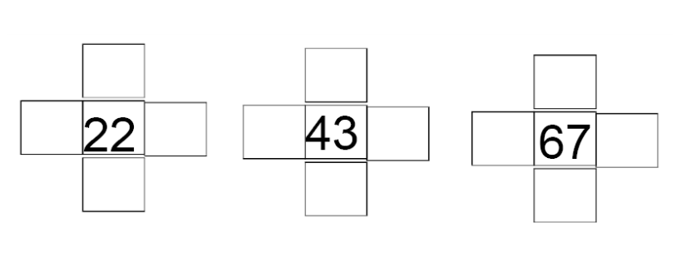

Use a hundred square or drawing to help you work out the answers to these questions:

33 + 6 = ____

48 + 8 = _____

25 + 33 = _____

51 + 44 = _____

48 – 7 = _____

88 – 10 = ____

43 – 21 = ____

100 – 100 = _______

What are these shapes called? Use these words to help:
oblong triangle hexagon pentagon cube pyramid cuboid cylinder

Look at the line of symmetry on this shape:

Now draw a line of symmetry on these shapes:

Which of these is wider?

Which of these is lighter?

INSERT Q

How do we weigh? In centimetres? In litres? In kilograms?

Draw a fish that is exactly 10 cm long.

Draw these times and then write the digital time.
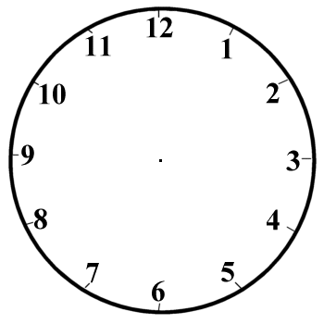

:
:
:

Half past 4 Quarter past 8 Quarter to 7

I get the train to London at 9 o’clock. It takes 3 hours to get there. What time do I arrive?

INSERT DATA HANDLING Q
Oral questions:

1 Add question
If I have 23 pence in my piggy bank and my mum gives me 12p more, how much money do I have altogether?

2 Take quest
Before I left for school my bag weighed 30 kg. When I got to school I took all my books and toys out. Now it weighs 10 kg. How much weight has it lost?

3 times quest
I eat 2 grapes every day of the week. How many grapes do I eat in one week?

4 divide quest
I have 8 chocolate squares to share between my four friends. How many pieces do they get each?

5 pattern
What comes next in this pattern? 125 130 135 140

6 shape turn
Draw a face. Show me what the face will look like if it is turned one quarter turn clockwise.

7 write down number
Write down this number. 234.

8 multiple calc
I love to play marbles. On Monday I had 6 marbles. On Tuesday I lost 4 marbles. On Wednesday I got 2 marbles. On Thursday I doubled the number of marbles I had. How many did I have then?

