Name: _______________________________ Date: ___________________

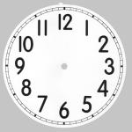
School starts at quarter to nine.

_____:_____
Lessons start at nine o’clock.

_____:_____

At half past ten it is playtime.

_____:_____

Playtime ends at quarter to eleven.

_____:_____

Lunchtime starts at quarter past twelve.

_____:_____

Lessons start at quarter past

one.

_____:_____
At quarter past three, it’s

time to go home!

_____:_____

