I can say the names of at least six zoo animals from memory with accurate pronunciation.
Animal | French
 | La souris
 | Le lion
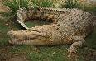 | La girafe
 | Le Tigre
 | Le singe
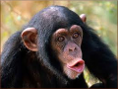 | Le Crocodile
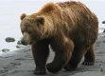 | L’éléphant
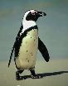 | L’ours
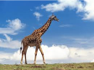 | Le pingouin

I can say the names of at least six zoo animals from memory with accurate pronunciation.
Animal | French

