**French Food**

1. *C:\Users\Becky Boo Boo\AppData\Local\Microsoft\Windows\Temporary Internet Files\Content.IE5\J1PL6MIX\MC900048792[1].wmf*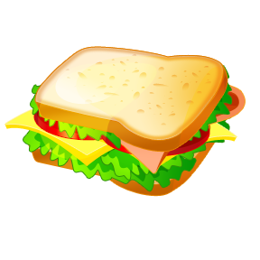C:\Users\Becky Boo Boo\AppData\Local\Microsoft\Windows\Temporary Internet Files\Content.IE5\PF6QQ319\MC900413448[1].wmfWrite the letter from the menu in the corresponding box.

***Le Menu***

1. *Un lait frappé*
2. *Un hamburger*
3. *Des frites*
4. *La soupe et du pain*
5. *Un sandwich*
6. *Œufs et du bacon*
7. *Spaghetti*
8. *La crème glacé*

C:\Users\Becky Boo Boo\AppData\Local\Microsoft\Windows\Temporary Internet Files\Content.IE5\PF6QQ319\MC900411892[1].wmf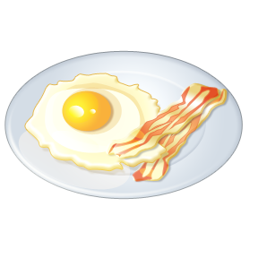C:\Users\Becky Boo Boo\AppData\Local\Microsoft\Windows\Temporary Internet Files\Content.IE5\06C9EE91\MC900264260[1].wmf

C:\Users\Becky Boo Boo\AppData\Local\Microsoft\Windows\Temporary Internet Files\Content.IE5\J1PL6MIX\MC900089354[1].wmf

1. Write a short paragraph describing what you had for dinner from the menu above. It can be made up, or real.

Je mangé…

________________________________________________________________________________________________________________________________________________________________________________________________________________________________________________________________

1. Describe your imaginary meal, mixing different foods together, and draw a picture.

Mon repas imaginaire est…

__________________________________________________________________________________________________________________________________________________________________________