LES ANIMAUX SAUVAGES

ours
chameau

crocodile

éléphant

hippopotame

iguane

girafe

gorille

kangourou
léopard

lion

singe

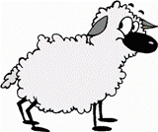



WORDS IN SINGULAR:

leaf strawberry
cherry sheep
person shelf
watch paintbrush
fox mouse
match puppy
knife tomato
loaf glass
potato sandwich
fish
panda

phoque
perroquet
rhinocéros

zébre

baleine

tigre

serpent

