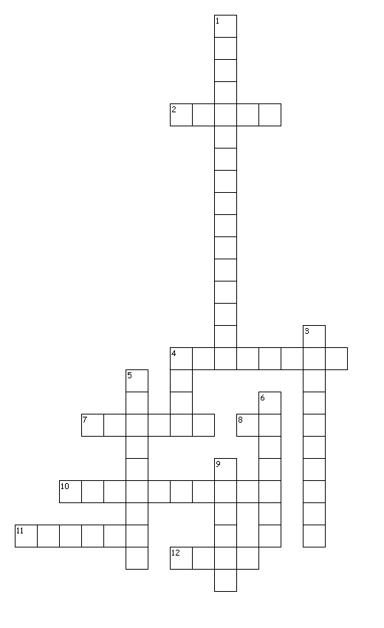
An Aimsir

Across
2. I need a drink.
4. My favourite weather!
7. Watch how you say this!!
8. You won't need your hat and scarf.
10. Rain on its way!
11. You'll need a torch.
12. You'll need your shades!
Down
1. Good weather for ducks.
3. Tie the trampoline down!
4. Watch out!Jack's about!
5. Wish our weather was like this more often.
6. Help!I can't see.
9. Too many beans,I think!

