Peter & the wolf
Put a number beside each character as you hear it.
The wolf | The cat
The bird | Peter
The duck | The grumpy Granda
The Hunters | Now can you write beside each character the instrument that plays them?

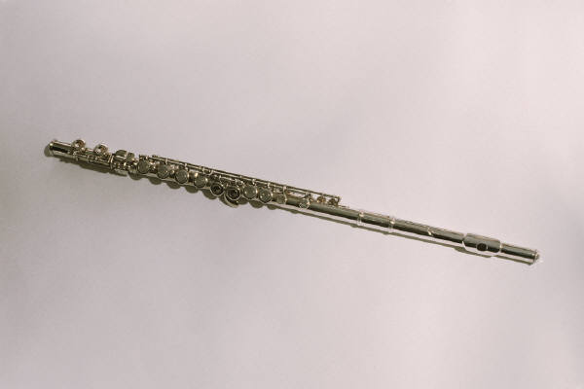
Write about the sound of each instrument as it is played. What character do you think it represents and why? Match the instruments and characters.
Peter & the wolf
The flute...
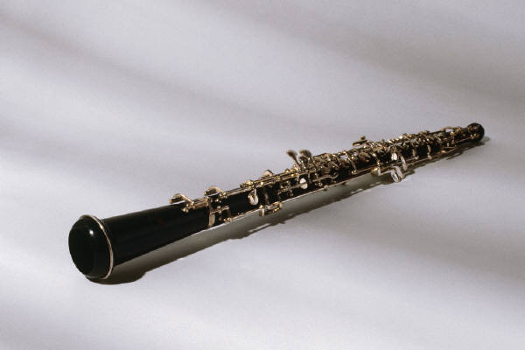
The oboe...

The drums...
The bassoon...

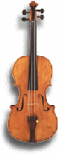
The strings...

The Horns...

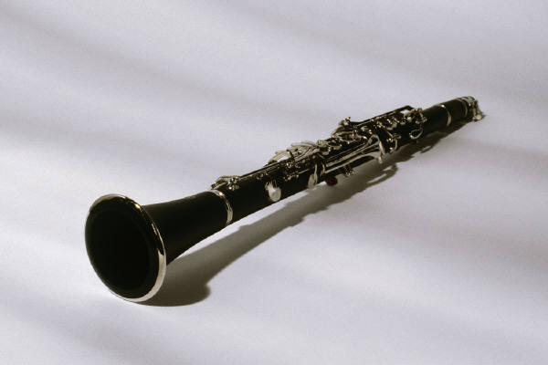
The clarinet...
Were you right?
Peter & the wolf

Listen to the music again.

How many times do you hear Peter’s theme tune?
What family of instruments play Peter’s tune?

What is the next tune you hear?

What two instruments play the argument between the duck and the bird?
How many times does the duck quack at the cat?

Describe Grandfather’s music – think of fast, slow, low high words.

What instrument plays the tune of the wolf?
What other instruments play?
How does this make you feel?
How many times does the wolf snap his teeth?

Name the instrument that plays the sound of the hunter’s guns?
What family of the orchestra do these belong to?

What happened to the wolf at the end of the story?

Whose tune is played at the end of the piece?

Primary 5 – Week 4 – Identifying musical themes and instruments

