Peter and the Wolf
By

Serge Prokofiev

Peter

The string family

The bird

The flute

The duck

The flute

The cat

The clarinet

The wolf

The Horns

Grandfather

The Bassoon

The Hunters

Drums

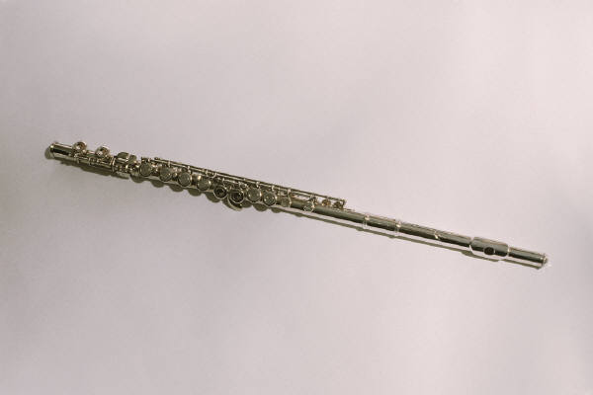
The flute

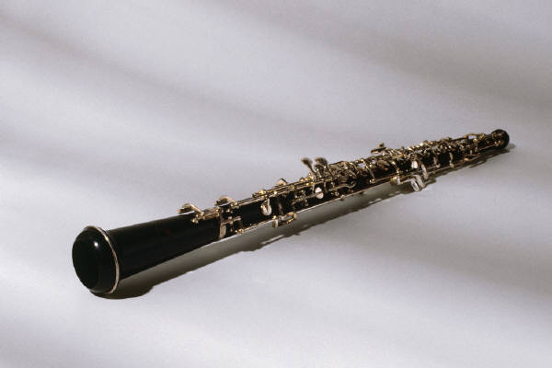

The oboe

The kettledrums

The bassoon

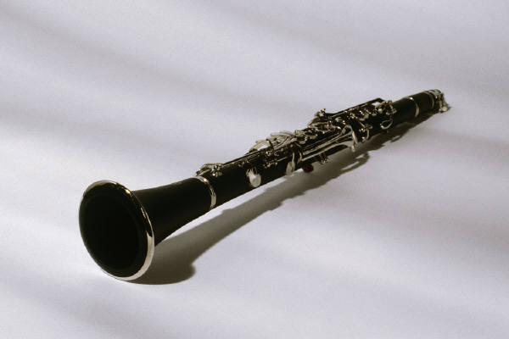
The clarinet

The horns

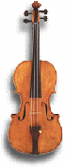

The violins - strings

