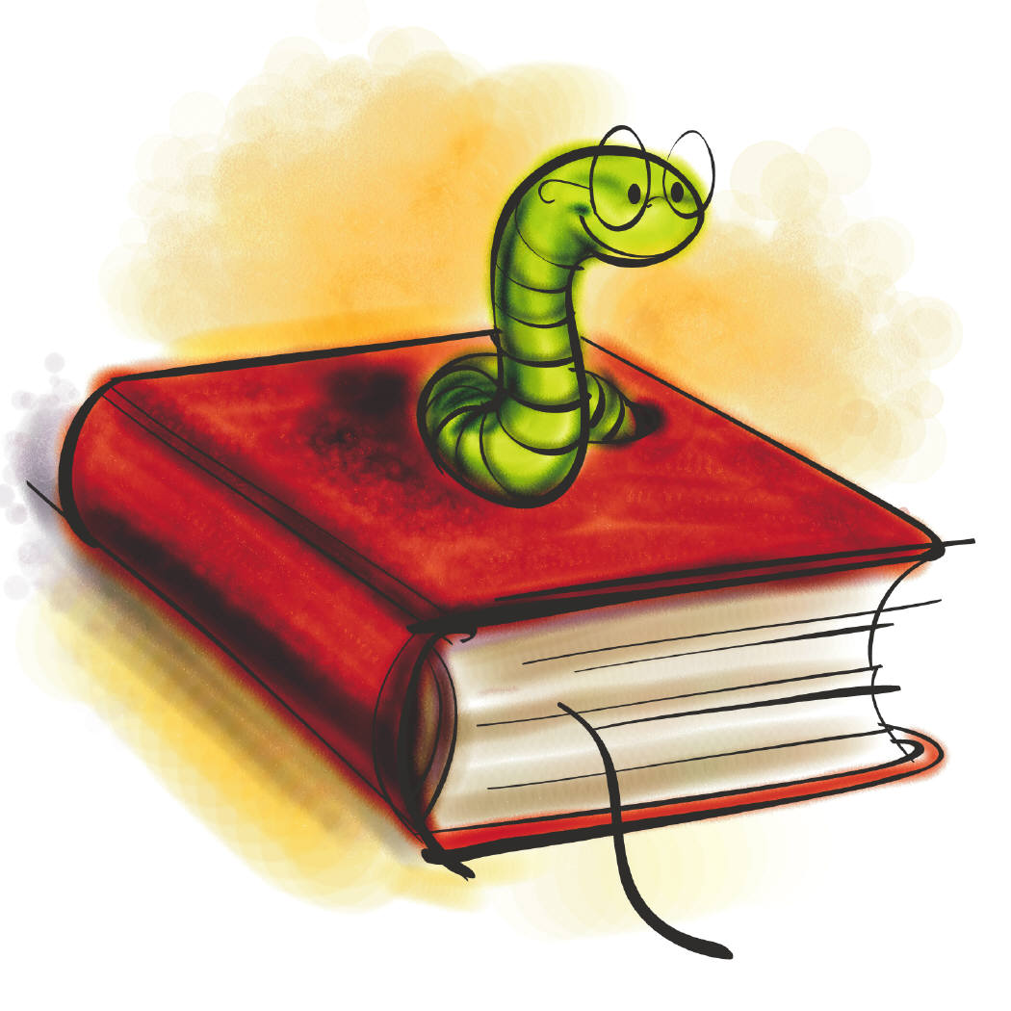
Literacy

Maths

Science

DT

Geography

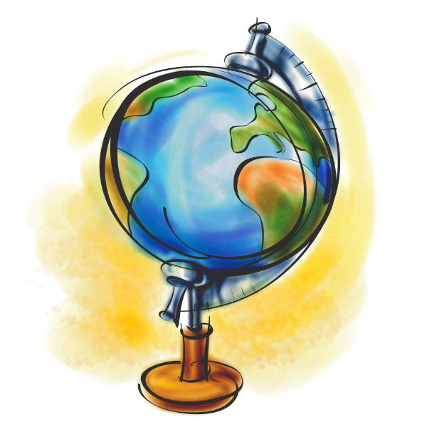

History

Circle Time
PE

Games

French

Guided Reading

ICT

Art
RE
Music

Break
LUNCH
Break

