Lesson 1 | Lesson 2 | Lesson 3 | Lesson 4 | Lesson 5
Something
Else
Craft
Art
Swimming
Quiet Reading

Literacy Games
Maths Games
Early Work
PE
Mental Maths
Science
Design Technology
Topic
History
Geography
ICT
PSHE
Music
French
Handwriting

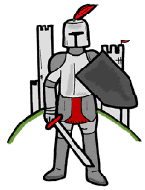

Citizenship
Religion Education
Literacy
Numeracy
Golden Time

