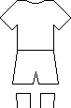
24
48
37

65
26
12
Draw a washing line in your book.

Cut out the shirts and hang them on the line in order. Start with the smallest number.

