School

This is your Pupil Progress File. In it you will keep a record of all your achievements in and out of school.

Its aim is for you to keep a clear record of all your achievements and future aspirations. It will give you the opportunity to think about your social skills, experiences, achievements, strengths, weaknesses and ambitions.

With help from your Form Tutor you will be deciding on areas to develop further, setting yourself targets with strategies for achieving them.

Your Pupil Progress File provides you with a way of keeping a record of all your achievements and abilities and will help you to make progress throughout your time at School.

You may like to include some of the following:
- Evidence of interests and activities outside school.
- Certificates
- Special awards or commendations for school activities.
- Work and awards from community and relevant groups.
- Personal targets you may set yourself, or that others have set for you.
- Your personal statement of achievement.
- Any charity work or contribution you may undertake such as fundraising
- Photographs
- Music and sports awards
- Examples of good work
- Copies of reports
- Photographs of experiences and achievements
- Test results
- Any particular moments that you are particularly proud of.

You will be responsible for updating it regularly and keeping it organised and neat.

Good Luck!

Name:

Date of Birth:

Address:

Social Interests:

Responsibilities:

Strengths:

Weaknesses:

Signed Date

Signed Date

Date | What I did | Evidence

Signed Date

Date | What I did | Evidence

Signed Date

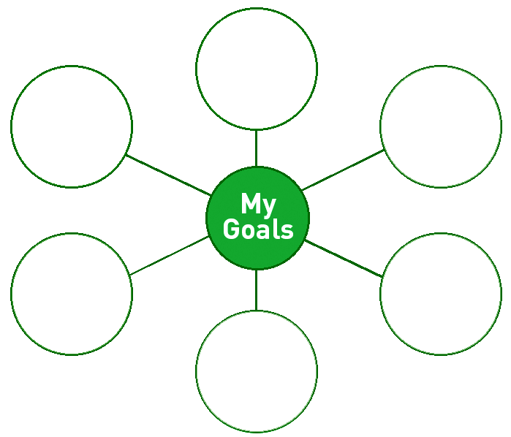

Signed Date

Signed Date

Signed Date

SUBJECT | ATTAINMENT |  |  |  | EFFORT |  |  |  | COMMENT
English | 1 | 2 | 3 | E |  | G | S | M
Maths
Science
Art
Design & Technology
French
Geography
History
Music
C & PSHE
PE
RE
ICT

Attainment:
1 – above National Curriculum
2 – NC standard
3 - below

Effort:
E = excellent
G = good
S = satisfactory
M = more effort needed

Signed Date
Instructions:
Below are 15 statements about ways of learning.
1. Look at each statement and decide how much it is like you.
2. Score each statement from 0 to 5. If it is like you, score it 5. If it is not like you at all, score it 0. Use the numbers in between as well. Circle your score.
3. Add all the scores using the key.

Not like me Really like me

1. I listen to music when I do my homework 0 1 2 3 4 5
2. I like it when we make things in class 0 1 2 3 4 5
3. To spell correctly I write it first 0 1 2 3 4 5
4. I remember how pages of my textbook look 0 1 2 3 4 5
5. I remember scenes from my favourite TV shows 0 1 2 3 4 5
6. Art is my favourite lesson 0 1 2 3 4 5
7. At break I like to run about a lot 0 1 2 3 4 5
8. I like the pictures in books the best 0 1 2 3 4 5
9. I can remember the words to songs 0 1 2 3 4 5
10. When I spell I see the word as I spell it 0 1 2 3 4 5
11. I know the theme tunes to my favourite TV shows 0 1 2 3 4 5
12. Singing is my favourite lesson 0 1 2 3 4 5
13. I’d rather play sport than watch it 0 1 2 3 4 5
14. PE is my favourite lesson 0 1 2 3 4 5
15. When I spell I say the word in my head 0 1 2 3 4 5

Visual Score
Question 4 ………
Question 5 ………
Question 6 ………
Question 8 ………
Question 10 ………
Total ………

Auditory Score
Question 1 ………
Question 9 ………
Question 11 ………
Question 12 ………
Question 15 ………
Total ………

Kinaesthetic Score
Question 2 ………
Question 3 ………
Question 7 ………
Question 13 ………
Question 14 ………
Total ………
What do your results show?

In what way or ways do you like learning best?

- By seeing things?
(visual ways)
- By hearing things?
(auditory ways)
- By doing or feeling things? (kinaesthetic ways)

I like learning best by:

Signed Date

Indicate on the scale (1-good, 5-bad) where you see yourself at present.

 | 1 | 2 | 3 | 4 | 5
Attendance
Confidence and self-esteem
Homework
Behaviour at school
Working with others
Relationship with adults
Involvement in school activities
Organisation

Take action with areas that are 4-5.

What action will you take?

Complete an action plan.

Signed Date

Target:

Action:

Target Review:

Signed Date

PERSONAL QUALITY EVIDENCE OF HOW USED

Signed Date
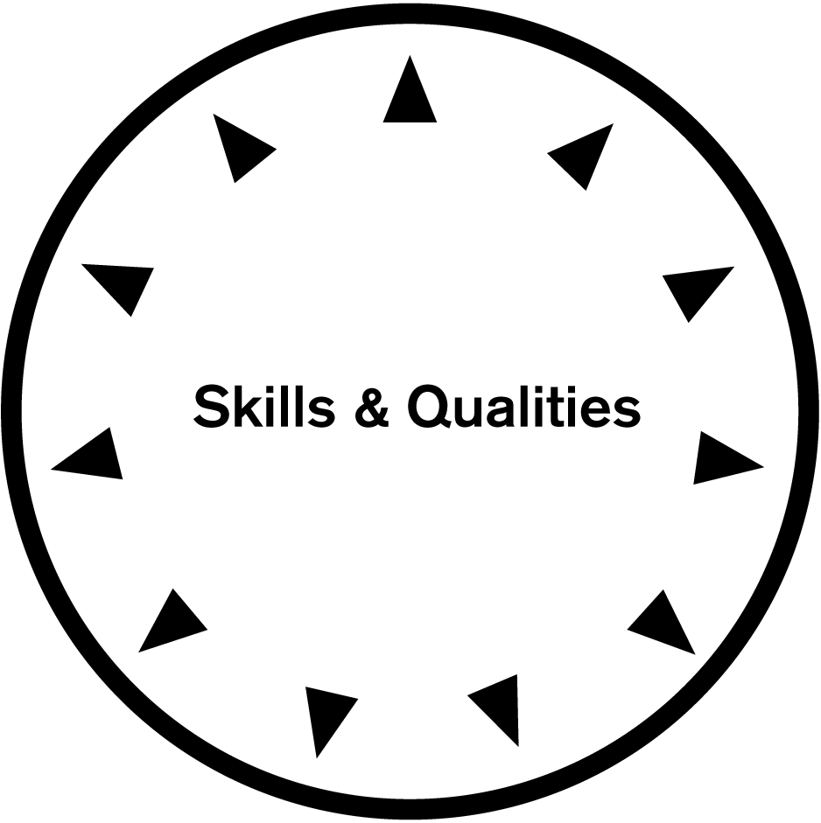
Year: ……………….
I was able to

Year: ……………….
I was able to
Year: …………………
I was able to
Year: ……………….
I was able to

Year: ……………….
I was able to
Year: …………………
I was able to

Year: ……………….
I was able to

Year: ……………….
I was able to

Year: ………………..
I was able to

Year:………………….
I was able to

Year: ……………….
I was able to

Signed Date

- One of the areas I would like to work in is…

- I would like to become involved in this area of work because….

- The personal skills that I think are necessary for this job are…

- The skill I need to develop the most is……

- The qualifications which I need for this job are

- To find out more about this job I am going to do the following research…

Signed Date

