
What helped you when something got
tricky about learning to ... ?
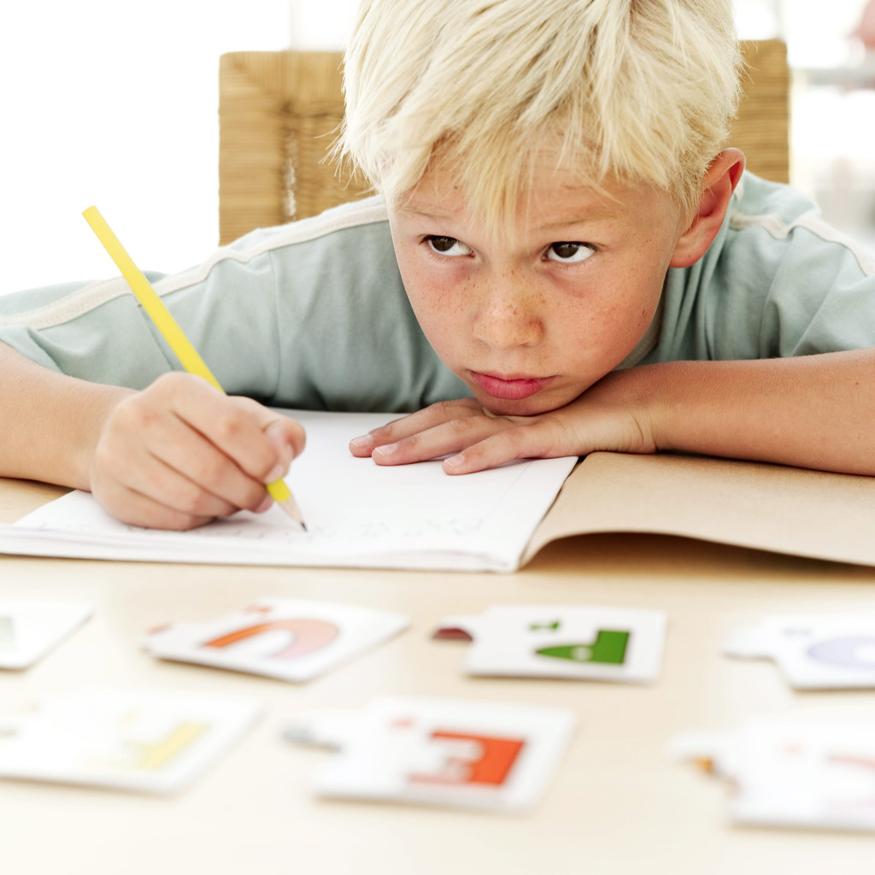
What did you find difficult
while you were learning to ... ?

What do you need
more help learning to ... ?

