Numeracy Guided Reading Literacy
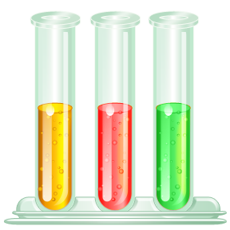
Science History Art
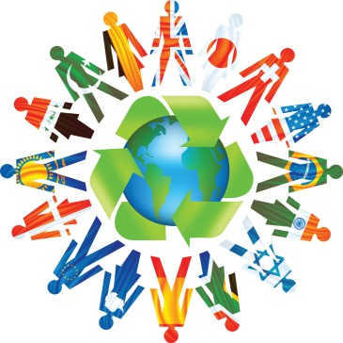
Religious Education Spellings Physical Education
Swimming ICT Design Technology
Geography Lunchtime Break time

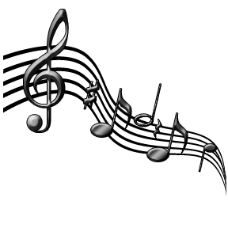
PSHE French Music

