w.mkjjekwj
% 18 +

- 7 x

56 > 21

Numeracy

Literacy

Science

Art

PE

History

Geography

Music

RE

ICT

Design and Technology

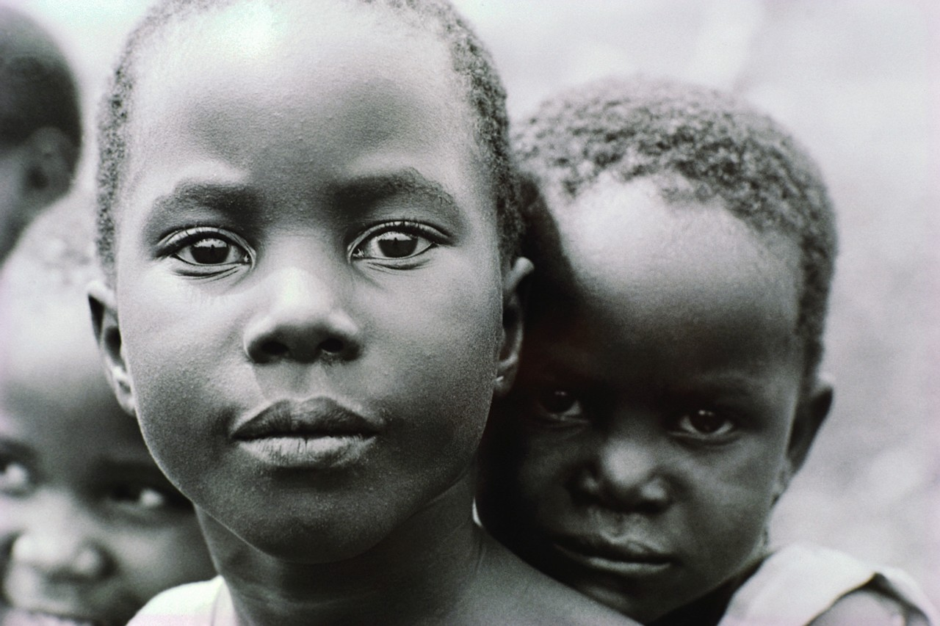

PSHE

Register

Assembly

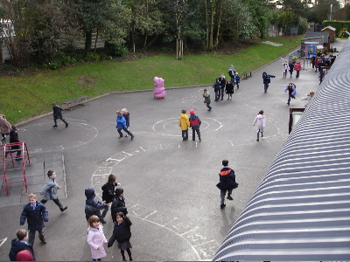
Playtime



Tidy up

Learning time

Lunchtime

Story time

Library

Home time

Fruit break



Circle time

Golden time

M

Monday
Tu

Tuesday
W

Wednesday
Th

Thursday
F

Friday

