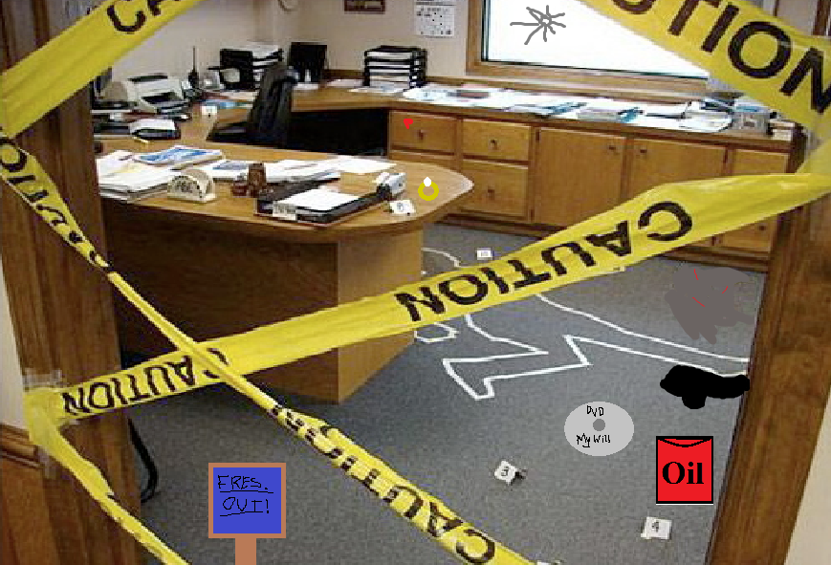

[Your Name]

Police Offico

Gressimdale UK

June 15, 2013

[Recipient Name]

Hope Society

Room 28, Gressinton Hotel

Dear Frederick Mills:

I am writing to you conserning the murder of Mayor John Freoburg of Gresointon town. I know that you hane been stawing nearey the scene of the crine so your infermation ceuld very much hedp. Pleasy contoct me un: 0187 332 7620.

Sincerery,

F. Harh

Thenk you fol your copperation.

**CRIME SCENE INVESTIGATION**

**Investigator: _____________ Date: _____________**

**Date & Time of Crime: _________________________**

**Victim(s): ____________________________________**

**Suspect(s): ___________________________________**

**Eyewitness(s): ________________________________**

**Crime description: ____________________________________________________________________________________________________________________________________________________________________________________________**

**Scene Address: Possible Weapons:**

**_______________________________________________________________**

**_______________________________________________________________**

**Scene description: ____________________________________________________________________________________________________________________________________________________________________________________________**

**Gressinton Town Ma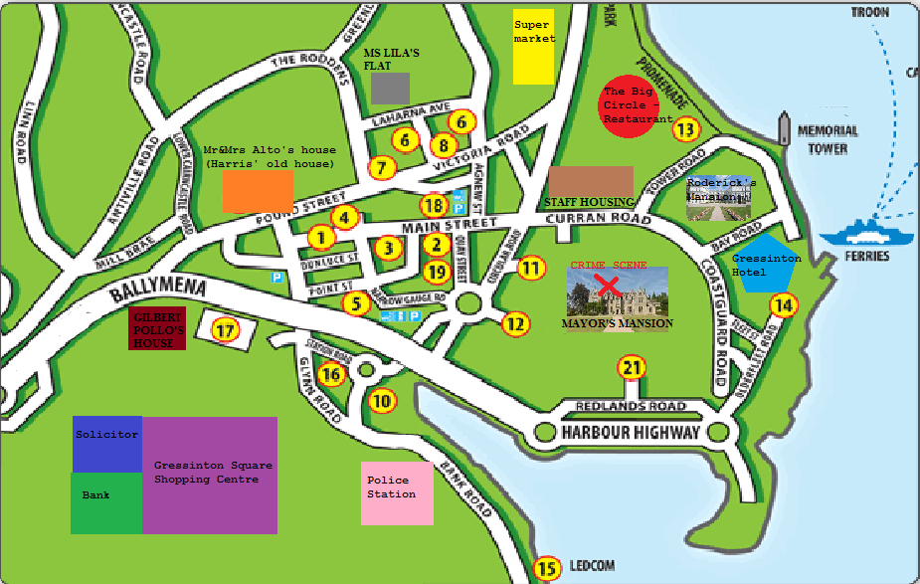p**

**C:\Users\Becky Boo Boo\AppData\Local\Microsoft\Windows\Temporary Internet Files\Content.IE5\U8XR719Z\MC900301364[1].wmfFactfile**

Party leader (opposing)

Gilbert Pollo

**Name: _____________ Job: ______________**

7/07/1991

**DOB: ______________ Gender: Male/Female**

Chelsea, Great Britain

**Birthplace: _______________________________**

Ballymena Way

**Address: __________________________________**

**Where were you on the night of the crime? _______________________________________________________________________________________________________________________________________________________________**

I was at the shopping centre, campaigning (as usual)

**Who was with you that night? _______________________________________________________________________________________________________________________________________________________________**

No one… everyone helping out had left, and I was putting the posters and signs away. The signs? They read ‘Fres. Out’.

**(If a witness) Describe what happened on the night of the crime: _______________________________________________________________________________________________________________________________________________________________**

**How do you know Mayor Fresburg? _______________________________________________________________________________________________________________________________________________________________**

I am his opposition in the political side of Gressinton.

**Did you like the Mayor? Why? _______________________________________________________________________________________________________________________________________________________________**

I wasn’t terribly keen of him, no but it was all fair game. His policies, they were just… outrageous.

**Official Statement: ____________________________________________________________________________________________________________________________________________________________________________________________________________________How H**

I know it doesn’t look good, me being on my own and all, but understand, I am a fair player, and killing the opponent is not something I’d even think of!

**C:\Users\Becky Boo Boo\AppData\Local\Microsoft\Windows\Temporary Internet Files\Content.IE5\U8XR719Z\MC900212101[1].wmfFactfile**

Cook for Mr Fresburg

Mrs Henrietta Kalle

**Name: _____________ Job: ______________**

11/02/1963

**DOB: ______________ Gender: Male/Female**

Ireland

**Birthplace: _______________________________**

Staff Housing for the Mayor

**Address: __________________________________**

**Where were you on the night of the crime? _______________________________________________________________________________________________________________________________________________________________**

I was in the kitchen preparing dinner, my speciality – lasagne.

**Who was with you that night? _______________________________________________________________________________________________________________________________________________________________**

It was just Marie – she was helping with dinner – and Harris, who was writing… something, I can’t remember what it was. It was just another normal night. No visitors, no.

**(If a witness) Describe what happened on the night of the crime: _______________________________________________________________________________________________________________________________________________________________**

I was peeling the carrots and I heard this thump from upstairs, and I thought it was just Mr Fresburg, in a tantrum – it used to happen quite often, he was always very tense and worried – but then… I heard this loud sound,like a gunshot, and I jumped. Harris went out to see what was going on. I was ever so scared.

**How do you know Mayor Fresburg? _______________________________________________________________________________________________________________________________________________________________**

I worked for him.

**Did you like the Mayor? Why? _______________________________________________________________________________________________________________________________________________________________**

I wasn’t extremely fond of the mayor, but come to think of it, no one was. He was always concerned, in fact. I never saw him smile in all my time working for him, but he was always lowering my pay, as he was with the others. I can’t tell you how many rants I had about that!

**Official Statement: ____________________________________________________________________________________________________________________________________________________________________________________________________________________How H**

As I said before, I am not particularly fond of Mr Fresburg, but I would never do anything like that, nor do I have any idea as to who it was. Sorry, but I can’t help you.

**C:\Users\Becky Boo Boo\AppData\Local\Microsoft\Windows\Temporary Internet Files\Content.IE5\LCIW1B9T\MC900301260[1].wmfFactfile**

Solicitor

Jonathon Williams

**Name: _____________ Job: ______________**

29/12/1959

**DOB: ______________ Gender: Male/Female**

Southampton, Great Britain

**Birthplace: _______________________________**

Bank Road

**Address: __________________________________**

**Where were you on the night of the crime? _______________________________________________________________________________________________________________________________________________________________**

At my shop, writing out some accounts

**Who was with you that night? _______________________________________________________________________________________________________________________________________________________________**

No one. It was just me.

**(If a witness) Describe what happened on the night of the crime: _______________________________________________________________________________________________________________________________________________________________**

**How do you know Mayor Fresburg? _______________________________________________________________________________________________________________________________________________________________**

I was his solicitor. And accountant, at one point, too. Golly, ever so much he spent on parties! But he always had enough. Sometimes I wondered where it all came from!

**Did you like the Mayor? Why? _______________________________________________________________________________________________________________________________________________________________**

Well, I was… friendly with him, but nothing more. He was just a customer. Come to think of it, he did come in a few days ago, asking about a will or something. But I wasn’t worried. Many people come about their wills as young as 20! Oh, I nearly forgot, his ex-wife came too and got the disc he recorded it on.

**Official Statement: ____________________________________________________________________________________________________________________________________________________________________________________________________________________How H**

I hardly knew him, and had nothing against him! Why would I do it?

**C:\Users\Becky Boo Boo\AppData\Local\Microsoft\Windows\Temporary Internet Files\Content.IE5\N1G4KQP1\MC900363248[1].wmfFactfile**

Marie Gandau

Maid for Mr. Fresburg

**Name: _____________ Job: ______________**

27/09/1986

**DOB: ______________ Gender: Male/Female**

France

**Birthplace: _______________________________**

Staff Housing, opposite the Mayor’s house

**Address: __________________________________**

**Where were you on the night of the crime? _______________________________________________________________________________________________________________________________________________________________**

I was in the kitchen of the house preparing some dinner. It was lasagne.

**Who was with you that night? _______________________________________________________________________________________________________________________________________________________________**

I was with Paul Harris, the butler, and the Cook, Mrs Kalle. No, there weren’t any visitors that I knew of. However, I did hear a sound from the basement. No one ever goes down there.

**(If a witness) Describe what happened on the night of the crime: _______________________________________________________________________________________________________________________________________________________________**

I heard a gunshot, and a sound like… like something falling on the floor, and something also being poured onto the floor, but Harris went to see what was happening and as soon as he opened the door, the sounds stopped. Harris found the mayor in the room, alone.

**How do you know Mayor Fresburg? _______________________________________________________________________________________________________________________________________________________________**

I’ve worked for him for several years, and I used to quite like him, But when Ms Lila left, he stopped throwing all his parties and balls. He was just lonely, I guess.

**Did you like the Mayor? Why? _______________________________________________________________________________________________________________________________________________________________**

I never overly liked him, he was very… snooty, as the English say. He never talked to me, and gave me a lower pay recently, as well as taking away my television from my room in the staff housing. I guess he was a job provider, and nothing more.

**Official Statement: ____________________________________________________________________________________________________________________________________________________________________________________________________________________How H**

I swear, I didn’t harm Mr, Fresburg, he wasn’t my best of friends, no, but I wouldn’t think for one second of… murdering him. I’m telling the truth, I promise. Even ask Harris and Mrs Kalle!

**C:\Users\Becky Boo Boo\AppData\Local\Microsoft\Windows\Temporary Internet Files\Content.IE5\74X977D1\MC900363212[1].wmfFactfile**

Restaurant Owner

Oliver Alto

**Name: _____________ Job: ______________**

13/11/1977

**DOB: ______________ Gender: Male/Female**

Great Britain, Manchester

**Birthplace: _______________________________**

Pound Street

**Address: __________________________________**

**Where were you on the night of the crime? _______________________________________________________________________________________________________________________________________________________________**

At the restaurant, cooking the dinner.

**Who was with you that night? _______________________________________________________________________________________________________________________________________________________________**

My wife, and the other chefs and waiters,

**(If a witness) Describe what happened on the night of the crime: _______________________________________________________________________________________________________________________________________________________________**

I wasn’t there, how am I supposed to know?

**How do you know Mayor Fresburg? _______________________________________________________________________________________________________________________________________________________________**

I am the owner of the ‘Big Circle’ Restaurant, and when I first met him, I was cooking for him – he was there for the opening of the restaurant,

**Did you like the Mayor? Why? _______________________________________________________________________________________________________________________________________________________________**

He gave me a terrible review to everyone in the town, on our opening night, and I thought that we’d have to shut down because there were so few customers. That really annoyed me, because every other customer said it was great!

**Official Statement: ____________________________________________________________________________________________________________________________________________________________________________________________________________________How H**

I didn’t like him that much, but not so much that I’d kill him! Do you seriously think that me, a bloke from Manchester, could have hurt him?

**C:\Users\Becky Boo Boo\AppData\Local\Microsoft\Windows\Temporary Internet Files\Content.IE5\74X977D1\MC900240465[1].wmfFactfile**

Butler

Paul Harris

**Name: _____________ Job: ______________**

26/04/1951

**DOB: ______________ Gender: Male/Female**

Great Britain, Gressindale

**Birthplace: _______________________________**

Staff Housing

**Address: __________________________________**

**Where were you on the night of the crime? _______________________________________________________________________________________________________________________________________________________________**

In the kitchen, writing out invitations to Mr Fresburg’s ball.

**Who was with you that night? _______________________________________________________________________________________________________________________________________________________________**

I was with Mrs Kalle, the cook, and Marie, the maid. If there was a visitor, I didn’t know about it. My hearing isn’t great though, so don’t trust me completely on that account!

**(If a witness) Describe what happened on the night of the crime: _______________________________________________________________________________________________________________________________________________________________**

I heard a gunshot, and went upstairs to look. No, I didn’t hear anything falling.

**How do you know Mayor Fresburg? _______________________________________________________________________________________________________________________________________________________________**

I have been his Butler for a good 18 years now, and his father’s before. In fact, Mr Fresburg and I grew up, here in Gressinton together.

**Did you like the Mayor? Why? _______________________________________________________________________________________________________________________________________________________________**

He was a very good friend of mine, up until last June. He lowered my pay, even though I’d been working here for years, and he forced me to move out of my house on Pound Street to the staff housing. I was ever so angry.

**Official Statement: ____________________________________________________________________________________________________________________________________________________________________________________________________________________How H**

We may have had our differences, me and the mayor, but I could never harm him – he was, and always will be, my dearest friend.

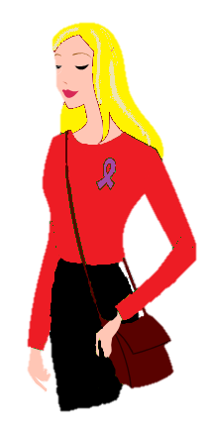**Factfile**

Hotel Manager

Penelope Lila

**Name: _____________ Job: ______________**

10/04/1975

**DOB: ______________ Gender: Male/Female**

Perth, Australia

**Birthplace: _______________________________**

Laharna Avenue

**Address: __________________________________**

**Where were you on the night of the crime? _______________________________________________________________________________________________________________________________________________________________**

At the hotel – I was shutting down the computer, then I went outside to drive home,

**Who was with you that night? _______________________________________________________________________________________________________________________________________________________________**

No one.

**(If a witness) Describe what happened on the night of the crime: _______________________________________________________________________________________________________________________________________________________________**

I wasn’t there, but I noticed something strange on my way home. I was driving past John’s house, and I saw some figures in the window of his office. There were 4 people there, One looked like Marie, the maid.

**How do you know Mayor Fresburg? _______________________________________________________________________________________________________________________________________________________________**

I’m his ex-wife, that’s why I know it’s strange that those people were there – he didn’t like visitors, they made him anxious. He never let me host a party. They were his worst nightmare, he said. After the divorce, I began supporting the opposing side. I volunteer sometimes.

**Did you like the Mayor? Why? _______________________________________________________________________________________________________________________________________________________________**

I used to love him, dearly, but he just began ignoring me, getting too busy with his work. He never seemed to care about me, and I proposed a divorce. I still love him, so I keep the ring on my finger every day. What? Where is the ring now? Oh… erm… must be at home.

**Official Statement: ____________________________________________________________________________________________________________________________________________________________________________________________________________________How H**

I loved him, and no matter how much he hurt me, he will always be the love of my life. I couldn’t ever hurt him.

**C:\Users\Becky Boo Boo\AppData\Local\Microsoft\Windows\Temporary Internet Files\Content.IE5\74X977D1\MC900059185[1].wmfFactfile**

Gressinton Ferries

Roderick West

**Name: _____________ Job: ______________**

16/09/1981

**DOB: ______________ Gender: Male/Female**

New York, U.S.A.

**Birthplace: _______________________________**

Tower Green (the big mansion near the mayor’s)

**Address: __________________________________**

**Where were you on the night of the crime? _______________________________________________________________________________________________________________________________________________________________**

I was out on the promenade, walking along the beach.

**Who was with you that night? _______________________________________________________________________________________________________________________________________________________________**

No one, I’m afraid.

**(If a witness) Describe what happened on the night of the crime: _______________________________________________________________________________________________________________________________________________________________**

I wasn’t there… but when walking back home, I saw a figure coming out of Memorial Tower. I’ll tell you a secret, that place is the entrance to a secret tunnel leading to the mayor’s mansion! It looked like they had a handbag, but I can’t be sure.

**How do you know Mayor Fresburg? _______________________________________________________________________________________________________________________________________________________________**

Ahhh, me and Fressie go right back, to when he was over in the U.S. on ‘business’ (holiday!) and we met in a club. I told him about my trade, and he told me that in his town in Britain, there a ferry industry that could be “worth millions” Hardly!

**Did you like the Mayor? Why? _______________________________________________________________________________________________________________________________________________________________**

He used to be a real good friend, but recently, he’s been trying to buy the ferry company off me. It just really annoyed me, you know?

**Official Statement: ____________________________________________________________________________________________________________________________________________________________________________________________________________________How H**

Fresburg and I – we were solid, and I would never let him get hurt. I’ll sure miss him, he was the only real friend I had here…