World Cup Maths Problems

- A game of football lasts 90 minutes.
Sven put Wayne Rooney on in the 34th minute of play. Wayne played until the end of the game with no extra time. How long did he play for?



- There are 7 players on the bench.

- What do their shirt numbers add up to?
Rio Ferdinand | 5
John Terry | 6
Frank Lampard | 8
Wayne Rooney | 9
Michael Owen | 10
Sol Campbell | 12
David James | 13
- If Sven put Sol Campbell on the pitch what would their shirt numbers add up to now?

- Peter Crouch scored a goal in the 87th minute of a match. Michael Owen scored a goal 49 minutes before Peter, in which minute did Michael Owen score?
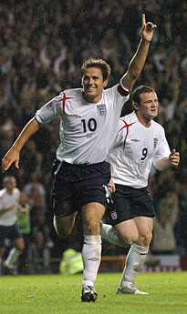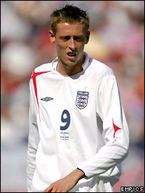

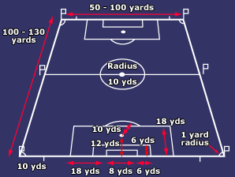
- A pitch is 100 yards in length and 50 yards wide. What is the perimeter of a football pitch?

5) If I walked from the edge of the 18 yard box (as marked) to the other end of the pitch (as marked), how far would I have walked?

6) If Gary Neville has 78 caps and David James has 33, how many more caps has Gary got than David?
Gary Neville  David James

7) After a game against Brazil, John Terry shook hands with all 11 players from the other team. How many fingers (including thumbs) did John Terry touch?
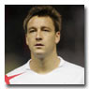 John Terry

8) Frank Lampard only shook hands with 7 players, how many fingers (including thumbs) did he touch?
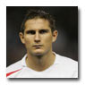 Frank Lampard

