Name ________________________________________________ Date ________________________________

GOING FOR GOALS
LO: I can set myself a goal or challenge

Who do you admire? ___________________________________ Draw a picture of them in the frame below.



Why do you admire them? ________________________________________________________________________

______________________________________________________________________________________________

What has this person achieved?
Why do you respect the person for this?
What obstacles were in his or her way?
How did he or she overcome them?
Who helped the person achieve their goal?
What do you think the person said/did when they felt like giving up?
Is there anything that the person had done in achieving their goals that you think they should not have done?

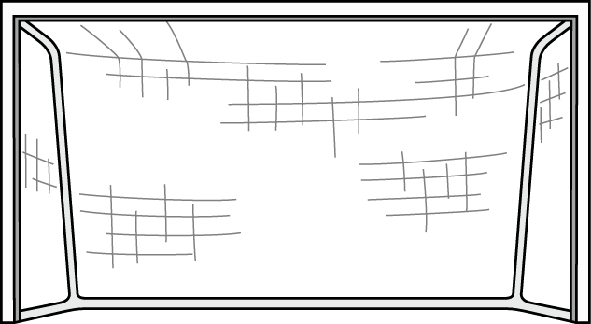
What would you like to achieve? It can be something when you grow up. Write it inside the goal

What you like to achieve at school? _____________

___________________________________________

___________________________________________

How can you do this? __________________________

_______________________________________________________________________________________________


Set yourself a goal that you can do in school.

Write it on the trophy.

