WALT: To consider what it means to be me.
Name:

Age:

Birthday:

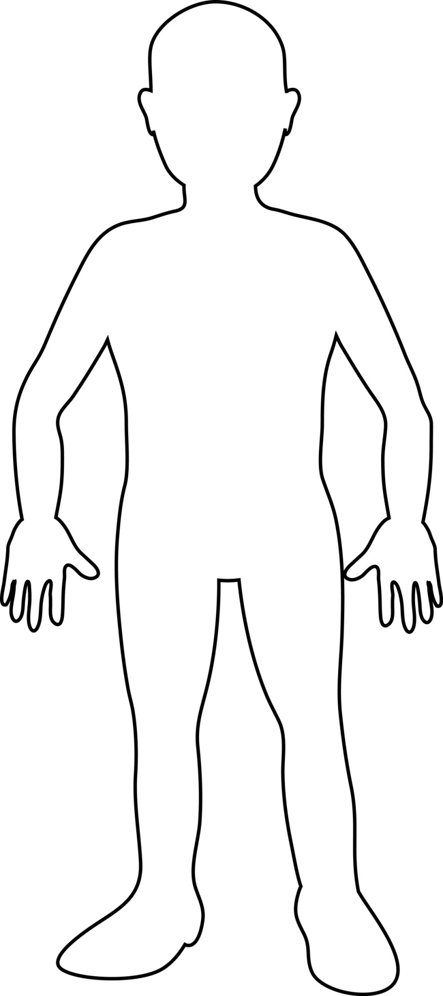
Family:

Friends:

Things I Like:

Other interesting things about me:

