Label all the different things you can see in the synagogue.

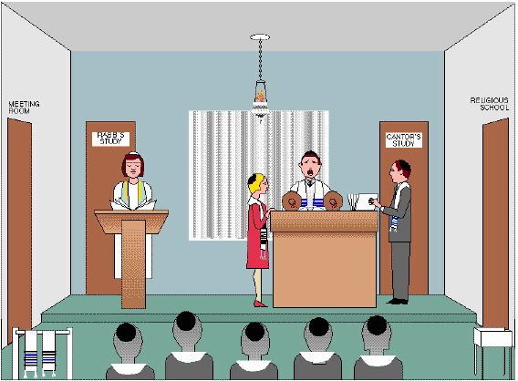

English Name | Hebrew Name | Purpose
Rabbi
Meeting Room
Tallit
Congregation
Kippah
School
Gabbaim
Cantor
Torah Reader
Ark
Eternal light

Answer these questions as fully as possible

- What is the symbol that is always seen around a synagogue?

- What does “synagogue” mean?

- What is unusual about the seating in a synagogue and why?

- What are the three main uses of a synagogue?

- Which way does the ark always face and why?

- What is the Torah?

- Why do people not want to touch the Torah with their fingers?

- What do they use instead? What is it’s Hebrew name?

- What is a mantle? What does it do?

- What is the purpose of the eternal light/

- What is a Menorah?

- What does it symbolise?

